Final Report for Project Entitled:
Reviewing the Standards for Wind-Driven Rain (WDR) Intrusion through Tracks of Sliding Glass Door Systems during Hurricanes
Revised and updated October 15th, 2024

Performance Period: 8/1/2024-12/1/2024

Submitted on:

Presented to,

Florida Building Commission
State of Florida Department of Business and Professional Regulation
By
Omar Nofal, Ph.D., omar.nofal@fiu.edu, (0970) 214-4716, Principal Investigator (FIU), Arindam Chowdhury, Ph.D., chowdhur@fiu.edu, (786) 801-7390, Co-Principal Investigators (FIU)
Ryan Catarelli, Ph.D., rcatarelli@ufl.edu, (727) 686-3901, Co-Principal Investigator

Department of Civil and Environmental Engineering (CEE)


Florida International University (FIU)

Executive Summary:
Past hurricanes have shown that wind-driven rain intrusion through sliding glass doors (SGDs) may cause severe interior damage, property loss, and health hazards from mold and mildew. Currently, some mitigation solutions can exhibit differing degrees of efficacy contingent on storm length, the severity of the rain, and wind forces exerted on the door systems, and the mitigation type. A comprehensive literature review is necessary to identify if the current standards are adequate to test SGDs and their capabilities to test the current mitigation devices in the market.
A literature review was conducted to identify if the current testing standards are sufficient to evaluate the performance of sliding glass doors and recommend any modification that needs to be done to improve the standards. The literature review includes the recent SGDs WDR intrusion testing standards, academic reports based on experimental testing, and impact reports from previous hurricanes such as the FEMA report on Hurricane Irma and Hurricane Matthew. The literature review process is guided by recommendations from the Technical Advisory Committee (TAC) and the final recommendations are suggested herein to the Florida Building Commission (FBC) Hurricane Research Advisory Committee (HRAC).

CONTENTS
EXECUTIVE SUMMARY: 2
Introduction 5
1.1 Background: 5
1.2 Motivation and Purpose of The Study 6
1.3 Project Goals 6
1.4 Project Tasks 6
A. Formation of a Technical Advisory Committee (TAC) 6
B. Reviewing Existing Literature And Standards and Reporting their applications to WDR Testing for Tracks of Sliding Glass Door Systems and Evaluation of Mitigation Methods 7
C. Formulate Recommendations 7
D. Expert Consultant 7
1.5 Deliverables 7
2. Literature Review: 8
2.1 Current Standards Testing for Sliding Glass Doors against WDR: 8
2.2 Improvements in Sealing and Drainage Designs are Required: 10
2.3 Performance Assessment of Door Tracks: 10
2.4 Mitigation Assessment Team Report: Hurricanes Irma and Maria in Puerto Rico 13
2.5 Mitigation Assessment Team Report: Hurricane Harvey in Texas Wind-Driven Rain: 13
2.6 Mitigation Assessment Team Report: Hurricane Michael in Florida Wind-Driven Rain: 14
2.7 Fiu Experiment on WDR on SGDs 16
2.8 Summary Of Storm Armour Testing and Reports 18
2.8 University Of Florida (UF) Experimental Testing Findings: 20
2.10 Summary Chart Of WDR Sliding Glass Window Experiments and Other Researches in Florida: 22
i). Performance Assessment of Door Tracks: 24
ii). Future Guidance: 27
iii). Impact of Real-World Scenarios: 27
3. Course of Action: 27
3.1 Recommendations 28
3.2 Retesting Protocols: 28
3.3 Laboratory Conditions: 28
3.4 Brand New System Validation: 29
4. Conclusions: 29
5. References: 30
6. Appendices 32
Appendix A: Meeting #1 Minutes– 12th September 2024 34
Appendix B: Meeting #2 Minutes – 25th September 2024 37
Appendix C: Meeting Minutes (Internal)– 11th October 2024 39
Appendix D: Meeting #3 Minutes– 17th October 2024 39

Introduction
Wind-driven rain (WDR) intrusion through sliding glass door installations is a serious hazard during hurricanes, especially in coastal areas like Florida. The failure of door systems to stop water from getting inside may result in significant structural damage, interior flooding, and expensive and long-lasting repairs.

1.1 Background:
Sliding glass doors are subjected to wind-driven rain (WDR) intrusion. Past hurricanes have shown that wind-driven rain intrusion into a structure may cause interior damage, property loss, and health hazards from mold and mildew. Currently, some mitigation solutions can exhibit differing degrees of efficacy contingent on storm length, the severity of the rain, and wind forces exerted on the door systems. A comprehensive literature review is necessary to uncover new improvements in protective technology and testing procedures. Several protective devices for rainwater penetration are now available on the market. However, their overall performance is yet to be validated.
Pursuant to Section 32 of HB 10 21 – 2024, the FBC has been tasked with performing a study on standards to prevent water intrusion through the tracks of sliding glass doors, including the consideration of devices designed to further prevent such water intrusion. By December 1, 2024, the Florida Building Commission is required to provide a written report of its recommendations to the Governor, the President of the Senate, the Speaker of the House of Representatives, and the chairs of the legislative appropriations committees and appropriate substantive committees with jurisdiction over chapter 718, Florida Statutes.
The water intrusion protection device provision in SB 1178 [references the consideration of devices designed to further prevent water intrusion. to a suggested specific mandate in Senate Bill 1178 that suggests buildings or structures to have certain devices or systems installed to reduce water intrusion. Water intrusion protection devices are designed to prevent water from entering a building through its envelope (walls, roof, doors, windows, etc.), particularly during severe weather events such as hurricanes or heavy horizontal rain. The FBC, in response to Florida legislation, has requested a study on standards to prevent water intrusion through the tracks of sliding glass doors, including the examination of devices intended to minimize or prevent water intrusion, following Section 32 of HB 10 21-2024 [6].

1.2 Motivation and Purpose of the Study
This final report aims to provide an overview of the project activities in the first month. This includes forming an advisory committee and assessing the performance of SGDs according to standards such as ASTM E331, ASTM E547, AAMA/WDMA/WDMA/CSA 101/I.S.2/A440, North American Fenestration Standard/Specification for windows, doors and skylights (NAFS), TAS 202, and Florida Building Code under real-world hurricane conditions.
The literature review will also identify gaps or weaknesses in the adopted testing methodology for SGDs and potentially make recommendations for improving the standards to increase the resilience of sliding glass door systems against WDR. The goal of this review is to improve building resilience and occupant safety by reducing water intrusion risks in hurricane-prone areas, ensuring that standards keep up with rising hurricane intensity due to climate change, and supporting better code development and compliance for architects, builders, and regulators.

1.3 Project Goals
This research aims to explore the current standards of testing sliding glass doors against wind rainfall intrusion through the tracks of sliding glass doors during storms, analyzing their performance and finding possible areas for improvement. The study focuses on determining how existing design and installation standards hold up to real-world hurricane circumstances supported by investigating recent experimental studies in large testing facilities. The literature will also cover forensic studies and field reconnaissance after extreme hurricane events. The study will include investigating current standards specifications in terms of the applied wind pressure intensity and duration and performing experimental simulations. A technical advisor committee will be formed to guide the literature review process and provide recommendations on the outcomes. The final recommendation will be presented to the Hurricane Research Advisory Committee for the Florida Building Commission to present any potential recommended modification to building codes and standards for sliding glass doors to enhance their performance against hurricane-induced WDR.

1.4 Project Tasks

a. Formation of a Technical Advisory Committee (TAC)
The objective of this task is to form a technical advisory committee (TAC) to guide the research program. TAC members shall represent different groups of practitioners and academics. This may include representatives from the fenestration and building component and cladding manufacturing industries, testing laboratories, architectural firms, engineering firms, and code officials. The role of this TAC will be to evaluate various methods of WDR testing and inform revisions to current testing protocols for studying WDR intrusion through tracks of sliding glass door systems. The TAC shall convene by video conference on a minimum of five occasions.

b. Reviewing Existing Literature and Standards and Reporting Their Applications to WDR Testing for Tracks of Sliding Glass Door Systems and Evaluation of Mitigation Methods

- Based on the recommendations from the technical advisory committee, FIU-CEE, and UF-CEE shall review current testing standards and relevant literature and reports related to WDR intrusion through tracks of sliding glass doors. This

- FIU-CEE shall research studies and test results on WDR experiments previously performed at the NHERI Wall of Wind Experimental Facility (WOW EF) at FIU and other facilities including the University of Florida NHERI EF.

- FIU-CEE shall provide a summary of the literature and testing review outlining the recommendations and conclusions of each research study reviewed.

c. Formulate Recommendations

In collaboration with the TAC and based on the literature review conducted under Item b, FIU-CEE shall develop recommendations regarding the applicability of the existing industry standards in testing WDR intrusion through tracks of sliding glass doors and evaluation of efficiency of mitigation devices and determine whether modifications and/or new protocols are needed for improved testing and evaluation.

d. Expert Consultant

FIU - CEE shall consult with the University of Florida and Dr. Catarelli shall serve as a consultant over the life of this project. Dr. Catarelli shall provide specific assistance in the following areas:

The University of Florida consultant will aid in the standards review based on the previous testing of the sliding glass doors conducted at the Powell Family Structures and Materials Laboratory at the University of Florida. Dr. Catarelli will also help in the forming of TAC.

1.5 Deliverables
- An interim report shall be prepared and delivered no later than September 16, 2024. The interim report shall cover progress to date on all tasks. This report will also serve as a progress update that details descriptions of any issues that may have been encountered. The interim report shall be formally presented to the Florida Building Commission’s Hurricane Research Advisory Committee at a time agreed to by the Contractor and Department’s Program Manager. The due date may be extended with the approval of the Program Manager.

- A draft final report shall be prepared and delivered no later than November 1, 2024, for comments by the Florida Building Commission’s Hurricane Research Advisory Committee. The report shall contain deliverables of all tasks discussed in Section 2. This shall include a clear outline of the problem statement, a summary of the literature and standards review, and recommendations regarding testing standards for testing WDR intrusion through tracks of sliding glass doors. The final report shall be prepared with revisions to address Hurricane Research Advisory Committee comments and delivered no later than November 15, 2024. In addition, the draft final report and the final report shall be formally presented to the Hurricane Research Advisory Committee at a time agreed to by the Contractor and Department’s Program Manager. The due date may be extended with the approval of the Program Manager.

2. Literature Review:
Hurricanes drive multiple direct and indirect hazards that can impact the building envelope and structural system. Wind rainfall intrusion is one of the most impactful hurricane-induced hazards that affects buildings, especially in Florida. The objective of this research is to assess the current standards for testing sliding glass doors against WDR. This will be done by reviewing the current standards in terms of the specifications for wind pressure intensity and duration compared to real-world hurricane circumstances supported by investigating recent experimental studies in large testing facilities. Therefore, the literature includes current standards for testing sliding glass doors, forensic and federal reports on hurricanes' impacts on sliding glass doors, experimental testing for sliding glass doors, and any peer-reviewed publications on the impact of wind-driven rain on sliding glass doors.

2.1 Current Standards Testing for Sliding Glass Doors against WDR:
There are multiple standards and installation restrictions to reduce wind rainfall intrusion through sliding glass doors. Below are the current Water Penetration Test Standards:

- TAS 202-94 – Criteria for Testing Impact and Nonimpact Resistant Building Envelope Components Using Uniform Static Air Pressure Loading
- AAMA/WDMA/CSA101/I.S.2/A440-22 – Standard Specifications for Windows, Doors, and Unit Skylights
- – Voluntary Performance Specification for Windows, Skylights and Glass Doors
- ASTM E 331 – Standard Test Method for Water Penetration of Exterior Windows, Skylights, Doors, and Curtain Walls by Uniform Static Air Pressure Difference
- ASTM E 547 – Standard Test Method for Water Penetration of Exterior Windows, Skylights, Doors, and Curtain Walls by Cyclic Static Air Pressure Difference
- ASTM E1105 – Standard Test Method for Field Determination of Water Penetration of Installed Exterior Windows, Skylights, Doors, and Curtain Walls by Uniform or Cyclic Static Air Pressure Difference
- ASTM E2128 – Standard Guide for Evaluating Water Leakage of Building Walls.
AAMA 520-09 and Product Grading: It is voluntary specification provides an optional rating of the ability of fenestration products (windows, doors, and unit skylights) to resist severe wind-driven rain. This voluntary specification is based on a rapidly pulsed pressure differential method, recognizing that conditions encountered during tropical storms, hurricanes, or severe thunderstorms are not static. In addition, the procedures and equipment required to perform the specified tests are provided. This is optional higher performance designations that clearly exceed the minimums established by the codes. These ratings are also not intended to supplant the water penetration values published in AAMA/WDMA/CSA 101/I.S.2/A440 and should be used for product comparison purposes only.

The dynamic pressure differential technique of the AAMA 520-09 standard offers a more accurate evaluation of fenestration products under hurricane circumstances. Nevertheless, the standard allows goods that do not satisfy these strict requirements to be placed in susceptible regions while providing an improved product rating based on resistance to WDR.

2023 FBC, Residential 8th Edition: Exterior windows and sliding doors shall be tested by an approved independent laboratory, and bear a label identifying manufacturer, performance characteristics, and approved inspection agency to indicate compliance with AAMA/WDMA/CSA 101/I.S.2/A440 or TAS 202 (HVHZ shall comply with TAS 202 and ASTM E1300). Exterior side-hinged doors shall be tested and labeled as conforming to AAMA/WDMA/CSA 101/I.S.2/A440 or ANSI/WMA 100 or comply with Section R609.5. Exterior windows and doors shall be labeled with a permanent label, marking, or etching providing traceability to the manufacturer and product. The following shall also be required either on a permanent label or on a temporary supplemental label applied by the manufacturer: information identifying the manufacturer, the product model/series number, positive and negative design pressure rating, product maximum size tested, impact-resistance rating if applicable, Florida product approval number or Miami-Dade product approval number applicable test standard(s), and approved product certification agency, testing laboratory, evaluation entity or Miami-Dade product approval.

• NAFS-22 Clause 0.2.5 Water Penetration Testing:
NAFS Clauses 6 and 8 outline the minimum water penetration resistance test pressure required to achieve a specific Performance Grade (PG). For Performance Classes R, LC, and CW, the test pressure must be at least 15% of the positive Allowable Stress Design (ASD) pressure associated with the PG. For Performance Class AW, the requirement increases to 20% of the positive ASD pressure. Regardless of product type, the water penetration resistance test pressure must never be less than 140 Pa (~2.92 psf) and is capped at 720 Pa (~15.04 psf). However, Clause 6.2.4 allows for exceptions where certain door systems can have water penetration resistance test pressures lower than these standard requirements.

NAFS-22 Clause 4.6.3.4: Water Penetration Resistance Test Pressure:
The Performance Grade (PG) rating for a product is sometimes limited by the structural performance rather than by water penetration resistance performance.
• In these cases, this can be indicated using a Secondary Designator on the label.
• Reporting a water penetration resistance test pressure below the PG requirement, down to 0 Pa (0.00 psf) shall be permitted for Limited Water (LW) side-hinged doors, dual-action side-hinged doors, sliding doors, and folding door systems.

ASTM E331 is referenced in NAFS-22 for products classified under the AW Performance Grade, which demands the highest level of performance among fenestration products. Additionally, it is indirectly incorporated in TAS 202-94, a standard mandatory for products sold within the High Velocity Hurricane Zone (HVHZ) encompassing Miami-Dade and Broward Counties. Compliance with this standard is essential for ensuring the durability and safety of sliding glass doors and other exterior assemblies in hurricane-prone regions.

The testing process utilizes specialized equipment, including a test chamber—either an open-sided box or one with a removable panel—where the specimen is installed and sealed. The air system, comprising a blower or compressed air supply, is designed to create the required air-pressure differentials across the specimen. This system must maintain constant airflow at a fixed pressure throughout the test duration to replicate real-world conditions accurately. The test provides critical data that informs product development and helps manufacturers meet stringent building codes and performance expectations for water infiltration resistance.

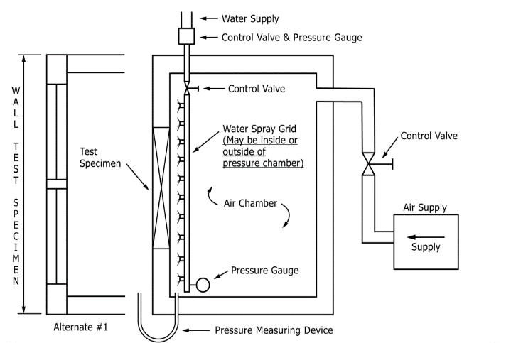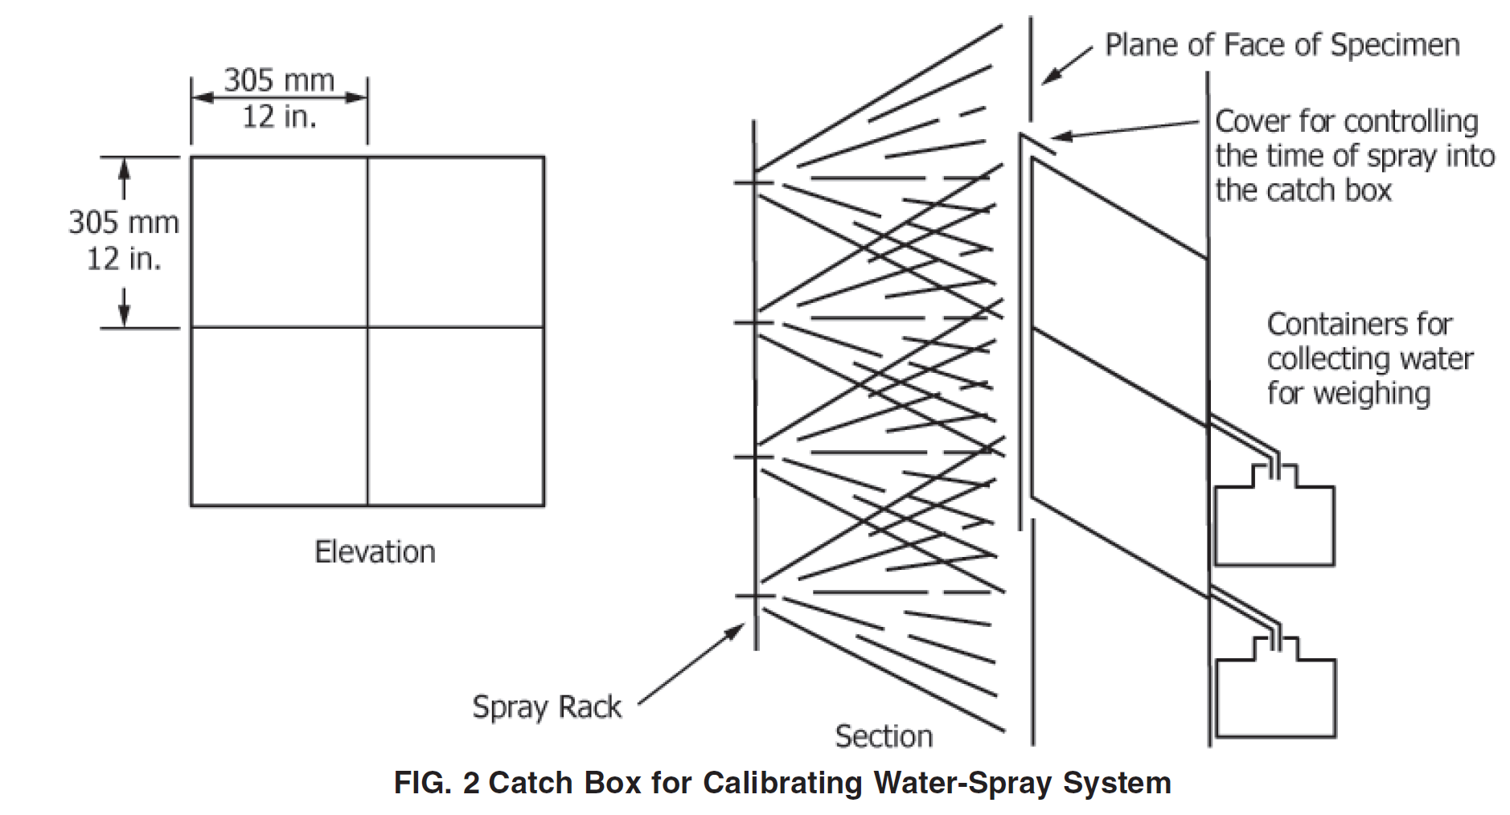

In addition to the test chamber and air system, the ASTM E331-00 (2016) standard requires specific equipment to ensure accurate measurement and effective water application during testing. One such critical component is the pressure-measuring apparatus, which is essential for determining the pressure difference across the specimen. This device must be calibrated to maintain a tolerance of 62% or 62.5 Pa (approximately 60.01 inches of water column), whichever value is greater. This precision is crucial as it directly influences the reliability of the test results, allowing for a thorough assessment of the water penetration resistance under varying air pressure conditions.

Furthermore, the water-spray system is designed to apply water uniformly across the exterior surface of the test specimen. To meet the requirements outlined in the ASTM standard, the system must deliver water at a minimum rate of 3.4 liters per square meter per minute (or 5.0 U.S. gallons per square foot per hour). This uniform distribution is critical for replicating realistic conditions and simulating the impact of heavy rainfall on sliding glass doors and other fenestration products during storm events. By maintaining these rigorous testing parameters, manufacturers can ensure that their products comply with industry standards and are capable of withstanding extreme weather conditions, ultimately enhancing the safety and durability of structures in hurricane-prone areas.

ASTM E547-00 (2016): The standard outlines a critical method for evaluating the water penetration resistance of exterior windows, curtain walls, skylights, and doors when subjected to cyclic air pressure. This test assesses how effectively these structures can withstand water intrusion when water is applied to the outdoor surface and edges simultaneously, alongside cyclic static air pressure that is higher on the outdoor face compared to the indoor side. ASTM E547 is specifically referenced in NAFS-22 for products rated under R, LC, CW, and AW categories, emphasizing its importance in ensuring the durability and reliability of fenestration systems.

The testing setup includes a test chamber—a sealed enclosure designed to facilitate the installation of the specimen—and an air system capable of generating the necessary air-pressure difference across the specimen. This system must provide consistent airflow at a fixed pressure throughout the test duration, mimicking real-world conditions that sliding glass doors and other fenestration products would face during severe weather events.

Central to the testing apparatus is the pressure-measuring apparatus, which monitors the pressure difference with a tolerance of 62% or 62.5 Pa (approximately 60.01 inches of water column), ensuring precise data collection. Additionally, the water-spray system is designed to deliver water uniformly against the test specimen at a minimum rate of 3.4 liters per square meter per minute (or 5.0 U.S. gallons per square foot per hour). This uniform application is crucial for accurately simulating the effects of wind-driven rain on these structures.

Moreover, calibration of the water-spray system must align with the requirements of ASTM E331 to guarantee consistent wetting of the specimen. Water penetration is defined in Section 3.2.3 of the standard as the intrusion of water beyond a vertical plane parallel to the glazing that intersects the innermost projection of the test specimen, excluding any interior trim and hardware. This definition underscores the significance of testing in establishing the integrity of building envelope components, and the NAFS-22 standard provides visual guidance for interpreting the critical measurements associated with this testing process.

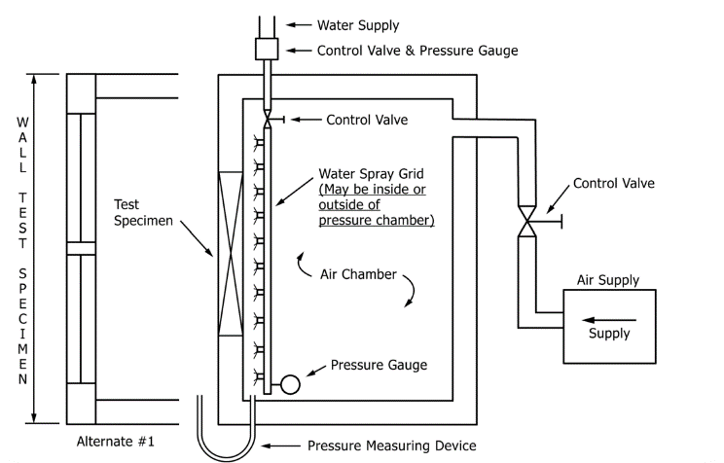

TAS 202-94: The TAS 202-94 standard offers essential guidelines for evaluating the performance of building components under uniform air pressure, with a particular emphasis on both impact and non-impact-resistant products. A key aspect of this standard is its specification for water testing, which mandates that components must endure a minimum water pressure equivalent to 15% of the positive allowable stress design (ASD) pressure for a duration of 15 minutes. This requirement serves as an indirect reference to ASTM E331, ensuring that products meet stringent water resistance criteria.

The testing procedure outlined in TAS 202-94 involves several critical steps to accurately assess the water penetration resistance of the test specimen. Initially, the test specimen must be securely installed within the test chamber to create a controlled environment for the assessment. Once in place, operable units are subjected to five cycles of opening, closing, and locking, simulating normal operational stresses prior to the water penetration test.

Following this preconditioning phase, the water spray is adjusted to achieve the specified rate, and the air-pressure difference is applied within a 15-second window. This pressure, combined with the water spray, must be maintained for the full 15-minute testing period to ensure that the components are thoroughly evaluated under realistic conditions. After the test duration, the air pressure and water spray are removed, and any observed water penetration is meticulously recorded. This systematic approach outlined in TAS 202-94 not only enhances the reliability of the testing process but also ensures that products meet the necessary performance standards to withstand harsh weather conditions.

SIMILARITIES IN TEST SEQUENCE IN BETWEEN TAS 202-94 & NAFS-22

TAS 202-94  - The sequence of testing for evaluating the performance of building components, particularly sliding glass doors (SGDs), involves a systematic approach designed to ensure comprehensive assessment under various conditions. Each load is held for 30 seconds to allow for accurate measurement and observation.  - Air Infiltration Testing: The procedure begins with testing for air infiltration according to ASTM E283. This standard determines the air leakage rates of the product, establishing its energy efficiency and potential for weather resistance.  - Application of Positive Loads: Next, the product is subjected to a load of 0.5 times the positive test load, which is calculated as 1.5 times the product's design pressure rating. This step is crucial for assessing the structural integrity of the component under reduced pressure conditions.  - Full Positive Design Pressure Load: After the initial load, the product is then loaded to its full positive design pressure. This step ensures that the component can withstand maximum anticipated pressures during a storm or extreme weather event.  - Negative Load Testing: The testing process is then repeated for negative loads, where steps 2 and 3 are applied again to evaluate the performance of the product under suction forces. This dual approach helps to understand how the component behaves under both positive and negative pressure conditions.  - Water Infiltration Resistance Testing: Following the load tests, the product is assessed for water infiltration resistance at the corresponding pressure, with a minimum requirement of 15% of the positive design load. This test determines the product’s ability to prevent water penetration under pressure, which is vital for ensuring durability and functionality during heavy rainfall or storms.  - Full Positive and Negative Test Loads: The next phase involves applying full positive and negative test loads to further validate the structural performance and resilience of the product under extreme conditions.  - Forced Entry Testing: Finally, forced entry testing is conducted to evaluate the security features of the product. This test simulates attempts to breach the door or window system, ensuring that it meets the necessary security standards. | NAFS-22 (R, LC, and CW products)  - The testing sequence for evaluating the performance of building components, particularly sliding glass doors (SGDs), employs a systematic approach that ensures a comprehensive assessment under various conditions. Each load during the testing process is held for 30 seconds, allowing for accurate measurements and observations.  - Air Infiltration Testing serves as the initial step, following the ASTM E283 standard, which assesses the air leakage rates of the product. This evaluation is crucial for establishing the component's energy efficiency and potential resistance to adverse weather conditions.  - The Application of Positive Loads occurs, where the product is subjected to a load of 0.5 times the positive test load. This load is calculated as 1.5 times the product's design pressure rating. This step is essential for determining the structural integrity of the component under reduced pressure conditions, thereby ensuring its reliability.  - The testing progresses to Full Positive Design Pressure Load, where the product is loaded to its full Positive Design Pressure. This ensures that the component can endure maximum anticipated pressures that may arise during storms or extreme weather events.  - Negative Load Testing then follows, where the same steps (application of 0.5 times and full positive design pressure) are repeated for negative loads. This dual approach provides insight into how the component performs under suction forces, allowing for a comprehensive understanding of its behavior under both positive and negative pressure conditions.  - Completing the load tests, the product undergoes Water Infiltration Resistance Testing at the corresponding pressure, with a minimum requirement of 15% of the positive design load. This assessment is critical in determining the product’s capability to prevent water penetration under pressure, which is vital for maintaining durability and functionality during heavy rainfall or storms.  - The testing phase then involves applying Full Positive and Negative Test Loads to further validate the structural performance and resilience of the product in extreme conditions.  - Forced Entry Testing is performed to evaluate the security features of the product. This test simulates attempts to breach the door or window system, ensuring that it complies with necessary security standards.

Standards Review
Testing Standards:
Compliance with AAMA/WDMA/CSA 101/I.S.2/A440 or TAS 202.2 (Testing Application Standard) is required for windows and doors, particularly in areas governed by the Florida Building Code, which mandates testing and labeling for regulatory compliance. In High-Velocity Hurricane Zones (HVHZ), all windows and doors must undergo and pass TAS 202 testing to ensure they meet stringent performance standards.

Overview of TAS 202 Testing Requirements:
TAS 202 evaluates water intrusion performance by applying differential static pressure (DP) tests. The process begins with 75% of the product’s designated DP, applied in both positive and negative directions for 30 seconds each. This cycle is then repeated at 150% DP for the same duration. After the door assembly successfully passes these static pressure tests, water is applied to the surface at a minimum rate of 5 gallons per hour (gph) per square foot, simulating approximately 8.02 inches of rain per hour. The rain simulation is performed with at least 15% of the product’s DP applied as static air pressure across the door for a minimum of 15 minutes.

For example, a product with a Performance Grade (PG) rating of 60 must pass a water penetration resistance test at 9 pounds per square foot (psf), corresponding to 15% of its positive DP rating. The PG rating reflects the product’s ability to resist water intrusion, with higher ratings indicating stronger performance. A PG 60 product demonstrates water penetration resistance at four times the pressure of a PG 15 product.

Performance Grade and Test Pressure Comparison:
The relationship between PG ratings and water resistance is crucial, as products with the same DP rating but different PG ratings undergo varying levels of water penetration resistance testing. For instance, while two products might share identical positive DP ratings, the one with a higher PG rating will face a more demanding water resistance test pressure, ensuring greater durability in extreme weather conditions. This distinction is illustrated in Table 1, where common PG ratings are compared against their respective test pressures to highlight the impact of performance grades on water penetration resistance.

Table 1: AAMA/WDMA/CSA 101/I.S.2/A440 PG Ratings – Wind Design Pressure and Water Penetration Resistance (Emergency Management Agency, F. (n.d.). Reducing Water Intrusion Through Windows and Doors.)
PG Rating | Wind DP Rating (positive) | Water Penetration Resistance Test Pressure (15% of PG Rating)
15 | 15 psf | 2.25 psf
30 | 30 psf | 4.5 psf
40 | 40 psf | 6 psf
40* | 50 psf* | 6 psf*
50* | 50 psf* | 7.5 psf*
60 | 60 psf | 9 psf
psf = pounds per square foot
*PG rating is less than DP rating

Key Recommendations:

For products tested to AAMA/WDMA/CSA 101/I.S.2/A440, it is essential to ensure that all windows and sliding doors have a Performance Grade (PG) rating that aligns with their positive DP rating. This alignment guarantees that the products meet both structural and water penetration resistance requirements under expected wind and rain conditions.

Matching PG and DP ratings ensures that the tested products can withstand not only static air pressure but also severe water intrusion events, making them suitable for use in regions with high hurricane exposure and other extreme weather conditions.

2.2 Improvements in Sealing and Drainage Designs Are Required:

Enhancing the draining capabilities and sealing mechanisms of sliding glass door (SGD) systems is essential to mitigating water intrusion during storms. Real-world data and simulation models show that inadequate drainage and inefficient seals are major contributors to water infiltration in extreme weather. However, existing structural testing standards, such as AAMA 910 (focused on mechanical durability and life cycle assessments), may underestimate long-term water infiltration risks under harsh weather conditions. These standards primarily address mechanical performance, raising concerns about whether structural integrity alone is sufficient to ensure resilience against wind-driven rain (WDR) during severe storms.

This highlights the importance of comprehensive performance evaluations that go beyond structural integrity to address water penetration risks. Particularly in hurricane-prone regions like Florida, construction standards must evolve to maintain the long-term functionality of SGD systems. Updates to the regulations are recommended to enhance the ability of windows and doors to withstand severe weather conditions and ensure effective WDR resistance.

Recommendations:

- Adopt stricter testing protocols: Implementation of more robust water resistance tests to complement existing mechanical durability assessments.

- Mandatory application of AAMA 520-09: This standard should be enforced to address the severe WDR resistance requirements for windows, doors, and skylights.

- Align PG and DP Ratings: For products tested under AAMA/WDMA/CSA 101/I.S.2/A440, ensure that the Performance Grade (PG) rating matches the product's positive design pressure (DP) rating for optimal performance.

- Improved installation and maintenance practices: Clear guidelines for proper installation and upkeep must be provided to contractors and homeowners to prevent water infiltration issues over time.

These measures will ensure SGD systems maintain their performance under both normal conditions and extreme weather events, safeguarding against potential damage and prolonging the lifespan of the products.

2.3 Performance Assessment of Door Tracks:
Essential performance requirements for windows, skylights, and glass door systems, including sliding glass doors, are provided by the Voluntary Performance Specification for Windows, Skylights, and Glass Doors (101/I.S. 2/NAFS-02), formerly known as ANSI/AAMA/NWWDA 101/I.S.2-97. These requirements are crucial in hurricane-prone areas like Florida. These guidelines are designed to guarantee that these systems operate dependably under a variety of environmental conditions, especially during severe weather conditions like hurricanes (AAMA, 2002).

The standard describes how items are categorized into several classes; products classified as Architectural Window (AW), and Heavy Commercial (HC) are especially important for hurricane-resistant constructions. To guarantee the systems' capacity to tolerate high wind loads, AW goods must adhere to the same minimum design pressure and structural test pressure standards as HC products (ANSI/AAMA/NWWDA, 1997). To reduce Wind-Driven Rain (WDR) incursion, AW products are usually subject to stricter regulations for air leakage and water penetration resistance (AAMA, 2002).

In the report (Architectural Manufacturers Association n.d.), the specification includes the deflection limit under uniform load, which is defined at L/175 for both AW and HC products. This is a critical performance criterion. This deflection restriction prevents excessive bending that might impair performance and guarantees that the glass doors' structural integrity is maintained under strong wind loads (AAMA, 2002). Furthermore, AW systems are better equipped to withstand water ingress during storms since the standard imposes greater water penetration resistance criteria on AW goods than HC products (ANSI/AAMA/NWWDA, 1997).

The requirement to pass the life cycle assessment described in AAMA 910, titled Voluntary 'Life Cycle' Specifications and Test Methods for Architectural Grade Windows and Sliding Glass Doors, is one of the characteristics that sets AW products apart. To make sure that moving parts, such as sliding glass doors, can endure continuous usage over time without degrading in function, life cycle testing evaluates the robustness and endurance of these parts (AAMA, 1997). The structural tests necessary for unglazed components—which apply to both AW and HC products—are supplemented by the life cycle testing (AAMA, 1997) [8].

Determine how well-sliding glass door tracks work to stop WDR penetration by concentrating on important design components such as drainage capability, sealing techniques, and track layouts. To determine the designs that resist water intrusion during storms the best, the study will evaluate several models and combinations.
Develop Recommendations for Standard Improvement: Provide ideas for enhancing the guidelines guiding the planning, implementation, and maintenance of sliding glass door systems based on data from simulations, experiments, and fieldwork. The purpose of these suggestions is to strengthen their ability to withstand WDR penetration under storm conditions.

Inform the Florida Building Commission of Findings: Provide the governing body with comprehensive information and suggested revisions to have an impact on foreseeable construction rules and laws. This contains recommendations for modifications to current guidelines to provide improved safeguards against water damage to houses and other structures during storms.

The AAMA 520-09 standard concentrates on how resilient windows, doors, and unit skylights are against heavy wind-driven rain, particularly during extreme weather events like hurricanes, tropical storms, or violent thunderstorms. These fenestration goods are usually chosen under state or municipal building code standards, either by their thermal performance or structural qualities. The main objective is to guarantee the product's structural integrity, which aids in preventing high-velocity winds from entering the structure and potentially causing fatal scenarios or significant damage to the structure.

But in scenarios when there is intense wind-driven precipitation, such as during hurricanes or tropical storms, items made to comply with normal code criteria could experience little or significant water intrusion. The claimed water penetration resistance of these goods is often exceeded by the severe wind-driven rain that these exceptional circumstances bring. This is especially problematic in coastal locations or locations where these kinds of catastrophic weather occurrences are common.

A voluntary grading system for fenestration goods that takes into consideration their resilience to intense wind-driven rain is provided by the AAMA 520-09 standard. The test procedure outlined in this publication is based on a quickly pulsed pressure differential approach, which recognizes that wind pressures encountered during hurricanes and tropical storms are dynamic rather than constant. By using this testing methodology, items are assessed in scenarios that more closely mimic the turbulence of actual storm situations.
Manufacturers and construction experts may choose products that are better suited for areas exposed to severe storms through the application of AAMA 520-09, which provides an internationally accepted test for wind-driven rain resistance. To better safeguard buildings from structural damage and water infiltration during severe weather events, fenestration materials must meet exacting standards of performance and durability. It is an effective means of differentiating goods from the competition. It guarantees that items in areas with elevated risks outperform specifications, providing increased safety for people and property in the case of severe weather.
The impact of wind on water intrusion through conventional sliding glass door systems installed in residential mid-rise buildings, using both analytical and empirical methods such as the research done at FIU by (Chowdhury et al. 2021) al on shuttered SGDs. To be certified as hurricane-resistant, SGDs must endure extensive testing to prove their strength and endurance against hurricane forces. Florida Building Code recommends many testing application standards for the assessment. Applying both positive and negative air pressure to the door surface and evaluating air filtration to look for leaks through the glass and frames are both part of the testing process. The door must also be able to tolerate changes in wind pressure and not exhibit any noticeable damage or deflection. High-pressure water evaluations are also performed on it to ensure there is no water intrusion. An air cannon is also used for impact testing, which mimics storm-thrown debris, to make sure the glass door is unharmed. Lastly, damage and deflection are measured using a cyclic wind strength test.
This report aims to provide an overview of the project activities in the first month. This includes forming an advisory committee and assessing the performance of SGDs according to standards such as TAS 202 - 94, AAMA/WDMA/CSA101/I.S.2/A440-22, AAMA/WDMA/101/I.S. 2/NAFS-02, ASTM E 331, ASTM E 547, ASTM E1105, ASTM E2128 and Florida Building Code under real-world hurricane conditions.
The literature review will also identify gaps or weaknesses in the adopted testing methodology for SGDs and make recommendations for improving the standards to increase the resilience of sliding glass door systems against WDR. The goal of this review is to improve building resilience and occupant safety by reducing water intrusion risks in hurricane-prone areas, ensuring that standards keep up with rising hurricane intensity due to climate change, and supporting better code development and compliance for architects, builders, and regulators.
2.4 Mitigation Assessment Team Report: Hurricanes Irma and Maria in Puerto Rico
From (Fema n.d.) numerous buildings showed water penetration from wind-driven rain, particularly via unsealed frames for windows and leaking roofs. However, infiltration was negligible in buildings with impact-resistant windows and high-quality seals, suggesting that appropriate design and material selection might reduce this risk.
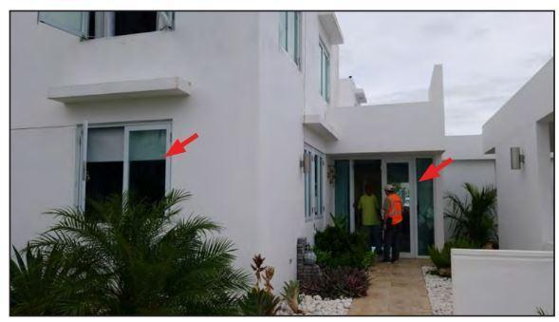
Figure 1: Concrete single-family home with impact-resistant glazing covering windows and doors (red arrows) (Ref: (Fema n.d.)).
Also, from (Fema, n.d.-b), these doors were especially vulnerable to strikes from debris and wind. Sliding glass doors sustained significant damage in many buildings, which, if premium materials or impact-resistant designs had not been utilized, might have resulted in water penetration and structural collapse.

2.5 Mitigation Assessment Team Report: Hurricane Harvey in Texas Wind-Driven Rain:
From the report (Mitigation Assessment Team Report Hurricane Harvey in Texas, n.d.), this was a significant problem, particularly in structures that were remodeled and had window frames that were weakened by debris strikes. To address this risk, the research highlights the need to update testing requirements for glazing equipment.
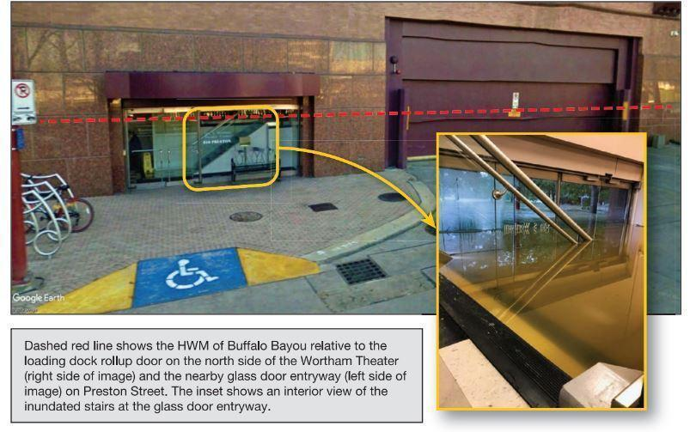
Figure 2: Floodwater entry point through glass door entryway. (Ref: Mitigation Assessment Team Report Hurricane Harvey in Texas. (n.d.).)
Also, in (Mitigation Assessment Team Report Hurricane Harvey in Texas, n.d.), Extensive damage was seen at the glass door entrances of business buildings, including the Wortham Theater, where wind and flood pressure caused the doors to burst. These places were not adequately safeguarded from flooding, which enabled rainwater to seep in.

2.6 Mitigation Assessment Team Report: Hurricane Michael in Florida Wind-Driven Rain:
From the report ((Emergency Management Agency 2001)), significant water penetration was observed in buildings because of wind-driven rain, particularly in shelters and vital facilities. This resulted in interior water damage and roof damage and had an impact on building occupancy and operation.
Also, according to (Emergency Management Agency, 2001), some glass sliding doors blew open or were completely blown away due to catastrophic failures brought on by wind loads and debris strikes. Many door assemblies did not function as planned, especially in situations when they were subjected to severe storm conditions.
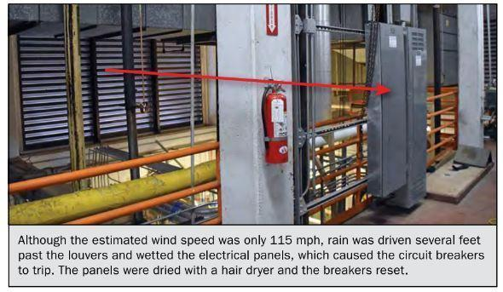
Figure 3: Wind-driven rain infiltration at a mechanical equipment room (Marianna, FL) (Ref: Emergency Management Agency, F. (2001). Mitigation Assessment Team Report: Hurricane Michael in Florida, Building Performance Observations, Recommendations, and Technical Guidance, FEMA P-2077/February 2020.).

The tests showed that sliding glass door systems, particularly those with track and sealing designs, cannot completely stop water intrusion under hurricanes' severe, dynamic conditions. These results are consistent with previous research, including studies by Moravej et al. (2021) and Vutukuru et al. (2024), demonstrating that wind loads may cause deformation of door joints and frames, aggravating WDR intrusion.
To evaluate the behavior of door frame joints under static nonlinear analysis, Moravej et al. (2021) used a three-dimensional finite element model to explore the impact of severe wind loads on sliding glass doors.
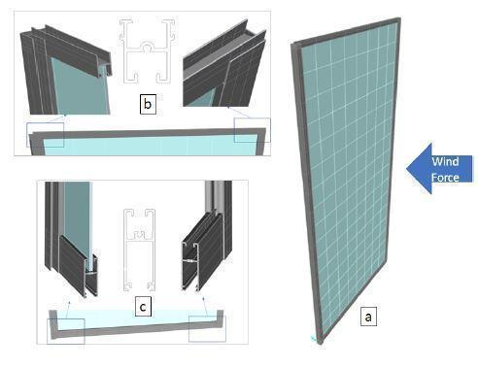
Figure: 4 3 D Model of sliding glass door (a) Full view (b) Top Panel (c) Bottom Panel
(Ref: Moravej, M., Arya, B., Simsir, C., & Jain, A. (2021). Impact of Extreme Wind Loads on Sliding Glass Doors. 6th American Association for Wind Engineering Workshop, Clemson University, SC, USA.)

According to the research, panel joints may be subjected to considerable bending and loads that are higher than the elastic limit, which might result in irreversible deformations. They underlined the need for thorough inspections as minor flaws like joint rotation and frame separation might impair the door system's overall performance in subsequent wind events.

2.7 FIU Experiment on WDR on SGDs
The study sheds important light on the weaknesses in building exterior components and the need for stronger design and inspection guidelines to increase resilience in the face of harsh weather. The consequences of wind-driven rain (WDR) intrusion on building interiors, especially during storms, are examined by Vutukuru et al. (2024). The research carried performed full-scale simulations with and without shutters to evaluate rain penetration through sliding glass doors under different wind conditions using the NHERI Wall of Wind Experimental Facility. Findings show considerable water incursion even below present design criteria, emphasizing how crucial realistic testing is to precise risk modeling and loss quantification. As per (Chowdhury et al. 2021)understanding how various elements, such as the speed and direction of the wind, and shutter usage, impact water intrusion into buildings is the primary objective of both the shutter mitigation effect of wind-driven rain (WDR) and the research on water intrusion via sliding glass doors.
TAS 201, 202, and 203 [14, 15, 16] may apply to Florida Building Code-established sliding glass door systems in the High-Velocity Hurricane Zone (HVHZ). TAS 201 evaluates windborne particle effects, TAS 202 tests uniform static air pressure and water penetration, and TAS 203 tests cyclic pressure loadings. Only TAS 202 applies to nonimpact-rated sliding glass doors. These testing standards experimentally validate door design pressure (DP), the uniform static positive or negative air pressure on a door system is supposed to tolerate service load.
Due to the testing parameters, only TAS 202 covers HVHZ water intrusion. Positive and negative 75% DP is applied for 30 seconds in the TAS 202 test procedure. At 150% DP, the identical 30-second process is repeated. After passing uniform static pressure testing, the door assembly receives 5 gallons per hour (gph) per square foot of water. The test specimen received 8.02 inches of rain per hour.
The rain simulation must be done during TAS with a minimum static air pressure of 15% DP above the sliding glass door for 15 minutes. We present two reasons why this approach is inadequate to evaluate a sliding glass door assembly's water resistance: First, under service conditions, water intrusion requirements are satisfied at 15% lower DP than hurricane-level WDR events for sliding glass doors. Second, static air pressure can measure the sliding glass door assembly's strength, but it cannot imitate the hurricane's wind and rain's dynamic, time-dependent assault. Even though wind-induced inertial force is a major factor driving water intrusion, standard test methods do not account for the dynamic interaction that may drive water through a suspected envelope flow.
Carry out a thorough examination of the rules and criteria that are currently in place for WDR penetration via sliding glass door tracks, paying special attention to those that apply to hurricane conditions in Miami. This entails evaluating the benefits and drawbacks of the current policies and finding any holes in the performance standards.
In the first investigation, several experiments were carried out to measure the total amount of water that entered a building under different circumstances using a sliding glass door system. At a straight wind direction of 0°, 65, 100, and 130 mph wind speeds were tested; at 65 mph, oblique wind directions of 22.5° and 45° were investigated. The impact of test length, which varied from three to fifteen minutes, on water infiltration was also investigated in this research. Within the structure, catch basins were used to collect water, and absorbent mats were used to manually collect any leftover water. Locations of water incursion were recorded using GoPro cameras. The findings demonstrated that water intrusion rose with wind speed and that shutters, namely accordion shutters and aluminum storm panels, significantly decreased the quantity of water that entered the structure as compared to the absence of shutters, particularly when direct wind impact was present.
The second case study examined how well accordion shutters and aluminum storm panels mitigated wind-driven debris (WDR) via a sliding glass door in three distinct wind directions: 45°, 22.5°, and 0°. To replicate a realistic field installation, the sliding glass door was erected in a tiny building model with walls made of reinforced concrete and fastened with concrete anchors. The research assessed Water infiltration with and without the two shutter systems. The findings showed that water infiltration reduced at oblique wind angles and became less severe at 0° (direct wind impact). Compared to accordion shutters, aluminum storm panels offered superior protection against WDR, especially at 0°; nonetheless, both shutter systems successfully decreased water penetration as compared to the absence of shutters.
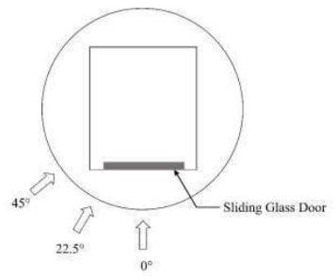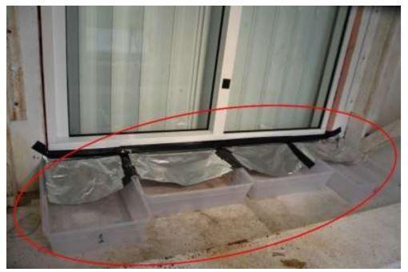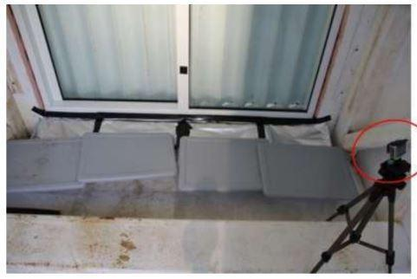
i. Experimental wind directions (plan view) ii. Interior view of water catch basins. iii. GoPro camera inside building
model during the water intrusion experiments

Figure: 5 Figures illustrating Experimental Wind Directions, Interior view of catch basins, & model during the water intrusion experiments (Vutukuru et al., 2024)

The results highlight how crucial it is to use shutters to reduce water penetration, especially when there are strong winds. The greatest danger of water penetration is caused by increased wind speeds and direct wind angles; however, shutter systems, particularly aluminum storm panels, greatly lessen this risk.
Recommendations:
- Inadequate Testing Pressure: The TAS 202 procedure tests water infiltration at only 15% design pressure (DP), much lower than what a sliding glass door might face during hurricanes, making it insufficient for real-world conditions.
- Lack of Dynamic Testing: The current test uses static air pressure, which does not simulate the dynamic effects of wind and rain during a storm. Wind-driven forces that promote water infiltration are not properly accounted for.
- Proposed Improvements: Incorporate realistic dynamic wind testing and assess how test duration impacts water infiltration to better evaluate the performance of sliding glass doors under hurricane conditions.

2.8 Summary of Storm Armour Testing and Reports
According to the report (StormArmour, n.d.), with promises of 99% water infiltration elimination, Storm Armour is a device designed to stop water intrusion in sliding doors with glass tracks during extreme weather. Numerous experiments, many of which are like earlier research by the Florida International University (FIU) Shutter Study, have been used to assess its efficacy. The FIU research found that water intrusion was a prevalent problem, particularly among non-shuttered sliding glass doors where water would mostly enter at the bottom, notably at the joints of the door sill and frame and where the glass met the aluminum.

Storm Armour carried out comprehensive testing within the FIU Wall of Wind in September 2023, according to even more stringent criteria than those utilized in the first FIU shutter research. Four distinct sliding glass door types were put through a total of 27 trials at 100 mph wind speeds in these tests. Interestingly, Storm Armour used twice as much water as the FIU testing, which concentrated on a single door and a pair of shutters. Storm Armour's exceptional performance in resisting water infiltration was shown by extensive testing; a statistical study revealed an average effectiveness of 97.74% across all door types.
While there were significant variations in the testing procedures, the Storm Armour tests largely matched the methodology and objectives of the FIU Shutter Study, according to a study from Al Farooq Engineering. The purpose of both experiments was to evaluate water resistance in comparable settings.
In the future, concerns have been raised about the cost of doing such extensive testing. The exorbitant expense of doing these tests—more than $500,000 per test for a four-door setup—and whether private enterprises should oversee paying their product assessments are important topics of discussion at an upcoming advisory conference. A suggested remedy is to replace the pass/fail test with a percentage-based efficacy evaluation, concentrating on setting a minimum water intrusion prevention threshold (e.g., 85% or 90%).
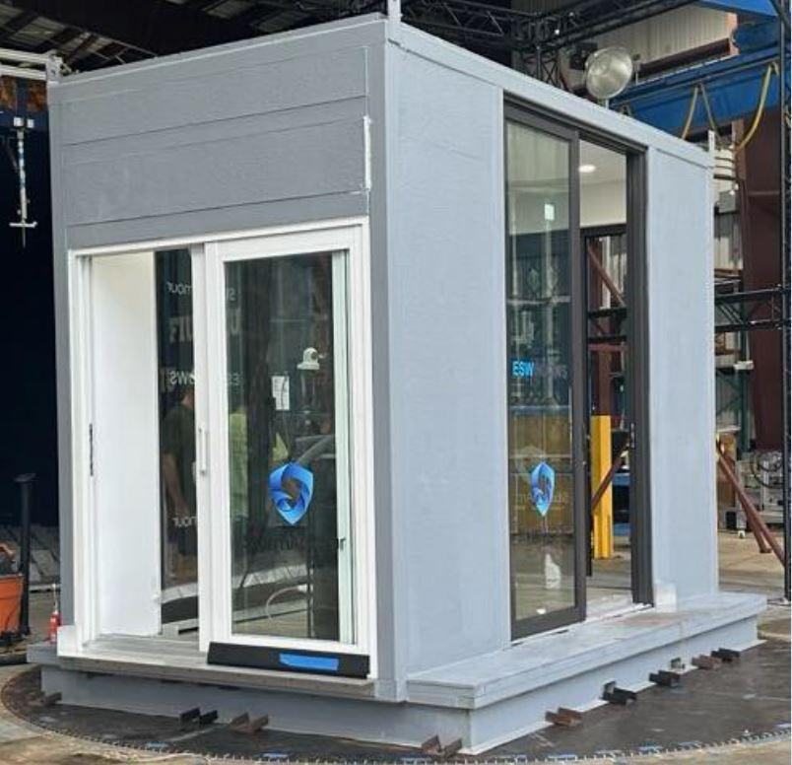
Figure:6 Building a cube-shaped structure will be necessary for testing numerous doors at once. (Ref: StormArmour, n.d.)

At now, Storm Armour is endeavoring to get Miami-Dade NOA certification. With a $500 pricing per unit and a five-year lifetime, the device is considered practical and well-priced in terms of cost and duration. The corporation also pledges to provide one set of Storm Armour to a person in need for every two sets bought, demonstrating their dedication to social responsibility and product effectiveness.

2.8 University of Florida (UF) Experimental Testing Findings:
During storm simulations, all specimens that passed ASTM E331/E547 testing demonstrated water infiltration. Because of turbulence, cyclic pressure lulls, and ambiguous wind load intensity criteria, current testing at lower pressures (<10 psf) are unable to predict the behavior of severe wind events.
Inadequate Wetting Rate: The 5.0 gph/sf wetting rate is based on antiquated techniques and ignores important variables (e.g., location, wind speed). It is inadequate to define failure as a single drop of water; harm is caused by accumulated water.
Test vs. Real-world Performance: Passing the present test requirements has little bearing on how well a hurricane performs in the real world. For unidentified causes unrelated to installation, several specimens failed. The performance of the sine sweep test is a strong predictor of the performance of storm simulations, indicating a possible future test technique.
Table 2: Summary of Water Penetration Testing Requirements in the FBCB and FBCR (Emergency Management Agency, F. (n.d.). Reducing Water Intrusion Through Windows and Doors.)
Product | Requirement | Outside the HVHZ |  |  | HVHZ
Windows and Sliding Doors | Testing Standards | AAMA/WDMA/CSA 101/I.S.2/A440 |  | TAS 202 | TAS 202
 | Water Penetration Resistance Test | 15% of PG |  | 15% of Positive DP Rating | 15% of DP Pressure Rating
 | Labeling Requirements | DP and PG |  | DP | DP
Side-swinging Doors | Testing Standards | AAMA/WDMA/CSA 101/I.S.2/A440 | TAS 202 | ASTM E330 | TAS 202
 | Water Penetration Resistance Test | 15% of PG | 15% of Positive DP Rating | None | 15% of DP Pressure Rating
 | Labeling Requirements | DP and PG | DP | DP | DP

PG Rating | Wind DP Rating (positive) | Water Penetration Resistance Test Pressure (15% of PG Rating)
15 | 15 psf | 2.25 psf
30 | 30 psf | 4.5 psf
40 | 40 psf | 6 psf
40* | 50 psf* | 6 psf*
50* | 50 psf* | 7.5 psf*
60 | 60 psf | 9 psf

2.10 Summary Chart of WDR Sliding Glass Window Experiments and Other Research in Florida:

Table 2: Summary Chart of WDR Sliding Glass Window Experiments and Other Research in Florida (Ref: Prevatt, D., et al. (n.d.).; Chowdhury, A. G., et al. (2021).; Catarelli, R. A., et al. (n.d.).

Research Source | Author | Report Title | Methods | Findings | Recommendations | Responsible Team | Institution | Objectives
Wind-Driven Rain Tests of Building Envelope Systems up to Hurricane-Strength Wind-Driven Rain Intensity.” | Prevatt, D., Smith, D., & Louis, M. | Test building envelope systems for WDR up to hurricane-strength conditions. | Simulations of wind-driven rain exposure at various intensities. | Found significant vulnerability in envelope systems under hurricane-level WDR. Suggested improvements in design to reduce moisture penetration. | Proposed updates to building codes to address extreme hurricane conditions, improving the resilience of envelope systems. | FBC Building Code Research | Florida Building Commission (FBC) | Research and code developments aimed at improving building resilience against WDR.
Quantification Of Wind-Driven Rain (Wdr) Intrusion Through Shuttered Sliding Glass Door Systems | Chowdhury, A. G., Erwin, J., & Vutukuru, K. S. | Quantify WDR intrusion through shuttered sliding glass door systems during hurricanes. | Experimental WDR exposure tests on sliding glass door systems, focusing on intrusion through shutters. | Documented significant water penetration through even shuttered systems under high-intensity WDR, especially around door tracks. | Proposed modifications to door design to better handle WDR. Suggests code changes for shuttered systems, especially for hurricane-prone areas. | FIU Wind Engineering & Hurricane Research Laboratory (WERL) | FIU (Dr. Chowdhury and team) | Performance of buildings and materials under extreme wind and rain conditions;  WDR studies specifically on sliding glass doors.
Assessing the Need to Modernize Water Penetration Resistance Test Procedures | Catarelli, R. A., & Phillips, B. M. | Assess the need to modernize water penetration resistance test procedures for building materials, particularly for sliding windows. | Review of existing test methods and performance evaluations, comparison to actual WDR conditions in Florida. | Identified gaps in current testing standards, which do not simulate actual hurricane WDR conditions adequately. | Recommended modernizing Florida Building Code (FBC) testing standards for water penetration, with updates to better reflect hurricane conditions. | UF Department of Civil & Coastal Engineering | UF (Dr. Catarelli and team) | Research into the effects of Wind-Driven Rain (WDR) on modern buildings;  Emphasis on water intrusion issues.

i). Performance Assessment of Door Tracks:
To assess sliding glass door systems' resistance to WDR incursion, conduct experimental testing in hurricane-like scenarios. This will include simulating the impacts of wind-driven rain at various intensities and orientations using wind tunnels and other pertinent modeling techniques.
Gather field data from past storms and genuine sliding glass door installations to see how these types of structures have historically behaved in real storm situations. Finding the probable causes of failure and the elements that contribute to WDR incursion is the goal.
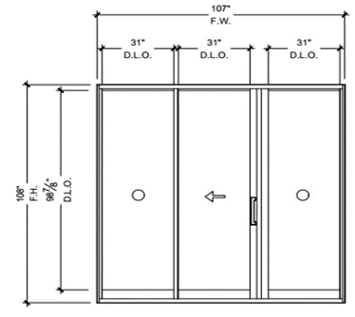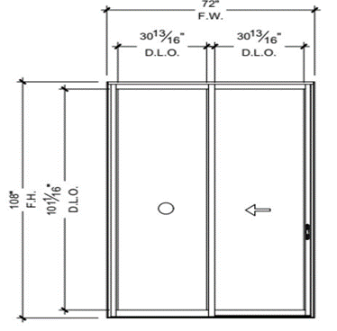
Elevation of ES-SGD2020 door model.  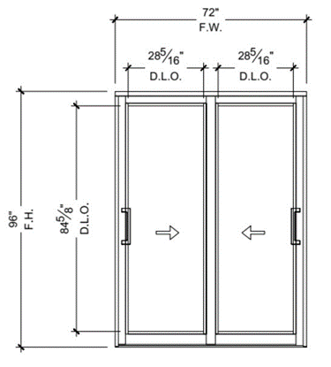 | Exterior elevation of ES-EL400 door model.  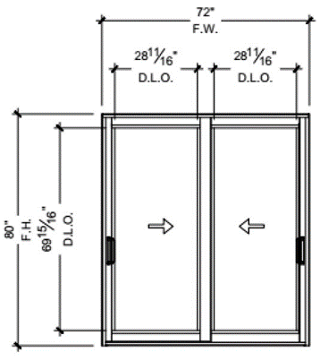
Exterior elevation of competitor #1 model. | Exterior elevation of competitor #2 door model.

Figure : Tested door models [Carlos E. Melchor, P. E. (2023). Statistical Analysis For STORMARMOUR TECHNICAL REPORT - A product of Storm Shield of Miami, INC. NC23-191(Certificate of Authorization # 8755), 1–18.]

As per Melchor, C. E., et al. (2023). Statistical Analysis for STORM ARMOUR TECHNICAL REPORT - A product of Storm Shield of Miami, INC. NC23-191 (Certificate of Authorization # 8755), 1–18. [25], Gather field data from past storms and genuine sliding glass door installations to see how these types of structures have historically behaved in real storm situations. Finding the probable causes of failure and the elements that contribute to WDR incursion is the goal.
The Storm Armour System is a set of components designed to improve the resilience of sliding glass door track systems against water intrusion during severe weather, such as hurricanes or high winds. The system is engineered to reduce the impact of strong winds and extended storm durations, aiming to protect against water leakage.
Tests were conducted on a steel-framed structure with sliding glass doors from three manufacturers. Four-door models were evaluated: ES-EL400, ES-SGD2020, and two competitor models. Testing involved multiple iterations under controlled conditions, including rain rates of 4 inches per hour and wind speeds ranging from 100 to 115 miles per hour for 5-minute durations. Results compared water intrusion volumes for each model, both with and without the Storm Armour system installed, showing the system's effectiveness in reducing water leakage across all tested door models. Data was recorded and summarized in Table 3 of the report.

Door Model | Grouping | Trial | Time (Min) | Wind Speed (MPH) | Rain Volume (in/hr) | Storm Armour (on/off) | Water Volume (lbs) After | Total Water Intrusion (lbs) | Total Water Intrusion (gallons) | Cups
ES-EL  400 | GROUP A | 1 | 5 | 115 | 4 | ON | 1.9 | 1.9 | 0.23 | 3.6
 |  | 2 | 5 | 115 | 4 | ON | 1.3 | 1.3 | 0.16 | 2.5
 |  | 3 | 5 | 115 | 4 | ON | 1.3 | 1.3 | 0.16 | 2.5
 | GROUP B | 4 | 5 | 115 | 4 | OFF | 46.6 | 46.6 | 5.58 | 89.3
 |  | 5 | 5 | 115 | 4 | OFF | 44.7 | 44.7 | 5.35 | 85.7
 |  | 6 | 5 | 115 | 4 | OFF | 46.9 | 46.9 | 5.62 | 89.9
ES-SGD  2020 | GROUP C | 7 | 5 | 100 | 4 | ON | 1.1 | 1.1 | 0.13 | 2.1
 |  | 8 | 5 | 100 | 4 | ON | 1 | 1 | 0.12 | 1.9
 |  | 9 | 5 | 100 | 4 | ON | 0.6 | 0.6 | 0.07 | 1.1
 |  | 10 | 5 | 100 | 4 | ON | 0.6 | 0.6 | 0.07 | 1.1
 | GROUP D | 11 | 5 | 100 | 4 | OFF | 44.4 | 44.4 | 5.32 | 85.1
 |  | 12 | 5 | 100 | 4 | OFF | 50.1 | 50.1 | 6 | 96
 |  | 13 | 5 | 100 | 4 | OFF | 49 | 49 | 5.87 | 93.9
 |  | 14 | 5 | 100 | 4 | OFF | 48 | 48 | 5.75 | 92
Competitor  #1 | GROUP A | 15 | 5 | 100 | 4 | ON | 0.3 | 0.3 | 0.04 | 0.6
 |  | 16 | 5 | 100 | 4 | ON | 0.4 | 0.4 | 0.05 | 0.8
 |  | 17 | 5 | 100 | 4 | ON | 0.2 | 0.2 | 0.02 | 0.4
 | GROUP B | 18 | 5 | 100 | 4 | OFF | 38 | 38 | 4.55 | 72.8
 |  | 19 | 5 | 100 | 4 | OFF | 40.5 | 40.5 | 4.85 | 77.6
 |  | 20 | 5 | 100 | 4 | OFF | 41.5 | 41.5 | 4.97 | 79.5
Competitor  #2 | GROUP A | 21 | 5 | 100 | 4 | ON | 1.1 | 1.1 | 0.13 | 2.1
 |  | 22 | 5 | 100 | 4 | ON | 1.3 | 1.3 | 0.16 | 2.5
 |  | 23 | 5 | 100 | 4 | ON | 2.2 | 2.2 | 0.26 | 4.2
 | GROUP B | 24 | 5 | 100 | 4 | OFF | 48.5 | 48.5 | 5.81 | 92.9
 |  | 25 | 5 | 100 | 4 | OFF | 46.4 | 46.4 | 5.56 | 88.9
 |  | 26 | 5 | 100 | 4 | OFF | 45.7 | 45.7 | 5.47 | 87.6
ES-SGD  2020 | GROUP 1 | 27 | 5 | 157 | 4 | SA on | 6.5 | 6.5 | 0.78 | 12.5

ii). Future Guidance:
As mentioned in Section 9.1, it is advised to create standardized testing protocols that include hurricane simulation to increase the resistance of sliding glass doors against wind-driven rain (WDR) during hurricanes. This standardized method should consider important variables such as building orientation, normal wind environments, door placement inside the building envelope, geographic location, wind angle of attack, and upwind terrain conditions. Through the consideration of these factors, the suggested guidelines have the potential to assess and improve sliding glass door performance, which would eventually increase the resilience of buildings in hurricane-prone locations.

iii). Impact of Real-World Scenarios:
At the NHERI Wall of Wind Experimental Facility, field simulations with hurricane conditions show that the existing standards may not fully capture the range of real-world weather situations. The limits of current models and testing settings were highlighted by the observation of water intrusion at levels below the current design criteria.

3. Course of Action:
To improve sliding glass door (SGD) performance against wind-driven rain (WDR), a more comprehensive and methodical testing strategy is advised. Initially, it is crucial to expand the testing's purview by putting in place an extensive test sequence that incorporates WDR assessments and ASTM standards on a greater range of SGD products from various manufacturers. Based on earlier studies, it is difficult to make reliable judgments about how well-tested units operate during hurricanes because of the small number of units that have been tested. A more reliable dataset for assessing the efficacy of different SGD designs will be made available by this increased testing.

Further enhancing the ability to predict current ASTM testing standards concerning real-world performance is the incorporation of differences in pressure levels and wetting rates. Given their established association with performance results, researchers are urged to investigate sine sweep tests as a stand-in for storm passage automobiles. Furthermore, by taking into consideration particular water ingress restrictions for various mean recurrence interval (MRI) storms, employing a performance-based design approach for pass/fail criteria would assist in guaranteeing SGDs fulfill rigorous standards dependent on the intensity of the storm. The goal of this complete framework is to improve the safety and structural integrity of residential buildings in hurricane-prone locations by strengthening the sliding glass doors' resistance to wind-driven rain.

3.1 Recommendations
- Adjust testing standards to incorporate equivalent wind speeds that reflect real-world conditions during hurricanes, ensuring tests better simulate extreme weather events.
- Revise static test pressure requirements to encompass higher dynamic pressures experienced during wind-driven rain (WDR) scenarios, addressing the limitations of current 15% DP testing protocols.
- The study investigates the effect of test duration on water intrusion through sliding glass doors.
- Measurement of the total volume of water intrusion over varying durations (3, 5, 10, 15 minutes) for each wind speed tested.
- Analysis of how water intrusion increases with longer test durations at different wind speeds and directions.
- Suggestions for optimal test durations that may better simulate real-world conditions, potentially leading to revisions in testing standards.

3.2 Retesting Protocols:
- The study may establish protocols for retesting to ensure reliability and repeatability of results.
- Detailed guidelines for repeating tests under controlled conditions to verify initial findings.
- Consideration of how factors like temperature, humidity, and previous exposure may affect retesting outcomes.
- Recommendations for changes in retesting based on observed data variability, particularly for different shutter systems.

3.3 Laboratory Conditions:
- Documentation of temperature, humidity, and other environmental factors during testing to ensure consistency.
- Analysis of how variations in laboratory conditions affect water intrusion results, potentially influencing test outcomes.
- Guidelines for preparing testing environments that minimize external variability, enhancing the reliability of results.

3.4 Brand New System Validation:
- Establishment of benchmarks for water intrusion resistance based on test findings for new sliding glass door designs.
- Assessment of how new designs meet or exceed Florida Building Code standards, particularly TAS 202.
- Suggestions for design improvements based on water intrusion performance, which could inform future manufacturing practices or building codes.

4. Conclusions:
The results of this research indicate that, particularly in areas susceptible to storms, a more thorough approach to regulating sliding glass door installations is required. The functioning of building systems under high wind and rain conditions has become a key safety concern due to the increased frequency and severity of these disasters.
The considerable water penetration seen during storm simulations indicates that testing procedures need to change. Although they are not widely used, standards like AAMA 520-09 provide more accurate models of dynamic wind pressures. Better protection for properties and residents would come from required laws that include these stricter testing procedures.
The paper that better drainage designs and sealing systems can only be developed via cooperation between engineers, architects, manufacturers, and code authorities. These upgrades would lessen the danger of water penetration during storms and better safeguard the structural integrity of SGDs.

WDR penetration has a substantial negative economic impact in addition to structural ramifications. Water damage may lead to expensive repairs, cause building occupants to relocate, and raise insurance claims. The building industry can lessen these cost constraints, especially in areas like Florida where storms are a regular danger, by raising the bar for WDR resistance.
The long-term robustness of SGD systems depends on life cycle testing conducted in circumstances that replicate real-world usage and weather events. Future code updates should place a strong emphasis on the marriage of structural performance, durability, and water resistance. Despite frequent storm exposure, this would guarantee that door systems continue to operate and be safe for the duration of their lives.

By using the data from this research, the Florida Building Commission may be presented with updates that are well-founded. Reducing residential and commercial buildings' vulnerability in hurricane-prone locations may need the adoption of stronger standards and more stringent testing procedures. Enacting laws that consider these discoveries would be crucial to safeguarding the security of buildings and their residents.

5. References:
- Moravej, M., Arya, B., Simsir, C., and Jain, A. Impact of Extreme Wind Loads on Sliding Glass Doors. (n.d.).
- Vutukuru, K. S., Chowdhury, A. G., and Erwin, J. "A case study and a full-scale simulation of wind-driven rain are used to assess how shutters reduce rain." 2024.
- Blocken, B., and Carmeliet, J. "A review of wind-driven rain research in building science." J. Wind Eng. Ind. Aerod., Vol. 92, (2004), pp. 1079–1130.
- Foroushani, S. S. M., Ge, H., and Naylor, D. "Effects of roof overhangs on wind-driven rain wetting of a low-rise cubic building: A numerical study." J. Wind Eng. Ind. Aerod., Vol. 125, (2014), pp. 38–51.
- Salzano, C. T., Masters, F. J., and Katsaros, J. D. "Water penetration resistance of residential window installation options for hurricane-prone areas." Build. Environ., Vol. 45, (2010), pp. 1373–1388.
- AAMA. AAMA 520-09: Voluntary Specification for Rating the Severe Wind-Driven Rain Resistance of Windows, Doors, and Unit Skylights. American Architectural Manufacturers Association, 2009.
- AAMA. AAMA 2501-06: Voluntary Guideline for Engineering Analysis of Window and Sliding Glass Door Anchorage Systems. American Architectural Manufacturers Association, 2006.
- AAMA. Voluntary 'Life Cycle' Specifications and Test Methods for Architectural Grade Windows and Sliding Glass Doors (AAMA 910). American Architectural Manufacturers Association, 1997.
- Architectural Manufacturers Association, A. AAMA 101-IS2: Voluntary Specifications for Aluminum, Vinyl (PVC), and Wood Windows and Glass Doors. (n.d.).
- American Architectural Manufacturers Association. AAMA 520-09 Voluntary Specification for Rating the Severe Wind-Driven Rain Resistance of Windows, Doors, and Unit Skylights. American Architectural Manufacturers Association, 2009.
- Building Commission, F. Facilitator’s Summary Report of the Florida Building Commission Meeting, Orlando, Florida: Process Design, Consensus-Building, and Facilitation. Facilitated Solutions, LLC, 2024.
- Senate, T. F., and Florida Governor Ron DeSanti. Florida House Version of the Bill Signed into Law. (2024).
- Chowdhury, A. G., Erwin, J., and Vutukuru, K. S. Quantification of Wind-Driven Rain (WDR) Intrusion Through Shuttered Sliding Glass Door Systems Final Report. 2021. https://doi.org/10.13140/RG.2.2.36806.86081
- International Code Council, Inc. "Testing Application Standard (TAS) 201-94 Impact Test Procedures." 2017 Florida Building Code—Test Protocols for High-Velocity Hurricane Zone. ISBN: 978-1-60983-688-7.
- International Code Council, Inc. "Testing Application Standard (TAS) 202-94 Criteria for Testing Impact and Nonimpact Resistant Building Envelope Components Using Uniform Static Air Pressure." 2017 Florida Building Code—Test Protocols for High-Velocity Hurricane Zone. ISBN: 978-1-60983-688-7.
- International Code Council, Inc. "Testing Application Standard (TAS) 203-94 Criteria for Testing Products Subject to Cyclic Wind Pressure Loading." 2017 Florida Building Code—Test Protocols for High-Velocity Hurricane Zone. ISBN: 978-1-60983-688-7.
- Catarelli, R. A., and Phillips, B. M. Final Report for Project Entitled: Assessing the Need to Modernize Water Penetration Resistance Test Procedures. Presented to the Florida Building Commission, State of Florida Department of Business and Professional Regulation, 2023.
- Krajewski, W. F., Ciach, G. J., McCollum, J. R., and Bacotiu, C. "Initial validation of the Global Precipitation Climatology Project monthly rainfall over the United States." Journal of Applied Meteorology, Vol. 39, No. 7, (2000), pp. 1071–1086.
- Emergency Management Agency, F. Reducing Water Intrusion Through Windows and Doors. (n.d.).
- FEMA. FEMA P-2020 Mitigation Assessment Team Report - Hurricanes Irma and Maria in Puerto Rico. (n.d.).
- *Mitigation Assessment Team Report Hurricane Harvey in Texas. (n.d.).
- Emergency Management Agency, F. Mitigation Assessment Team Report: Hurricane Michael in Florida, Building Performance Observations, Recommendations, and Technical Guidance. FEMA P-2077/February 2020.
- Storm Armour Eliminates up to 99% of Water Intrusion from Sliding Door Tracks During Severe Weather Conditions. (n.d.).
- Prevatt, D., Smith, D., and Louis, M. "Wind-Driven Rain Tests of Building Envelope Systems up to Hurricane-Strength Wind-Driven Rain Intensity." (n.d.).
- Melchor, C. E. Statistical Analysis for STORMARMOUR Technical Report - A Product of Storm Shield of Miami, Inc., NC23-191 (Certificate of Authorization # 8755), (2023), pp. 1–18.

6. APPENDICES

APPENDIX A: MEETING DISCUSSION POINTS SUMMARY (REFERS TO DETAILS IN THE MINUTES)
Table 1. Key Observations of Research Advisory Group
TAC members offered recommendations on resources to use for an extensive review during the team's discussion of the strategy for the literature review.
Window Manufacturers | TAS standards for structural loading before water testing in Miami Dade: design load without impact testing.  FBC has several reference installation standards.  Looking at better enforcement of standards (installation practices) developed by UF is an option.  Suggestion: Conduct a post-hurricane forensic assessment of actual buildings to identify the correlation between the buildings’ leak resistance and fenestration and envelope construction details.  Determine the minimum criteria to avoid a lot of issues and then there may be a maximum above which you get diminishing returns to have the water pressure that is highly rated. | M1
Building Consultants / Engineers | The study's findings may influence standards, which might have an impact on the 15% positive Design Pressure (DP) rating for Water Damage Resistance (WDR).  Current building codes and industry practices are not focused on preventing water intrusion in the aftermath of a hurricane. The focus is on structural performance and life safety.  Florida market is mainly concerned with structural problems and less concerned with water leakage issues.  No requirements for field testing fenestration after installation. Field testing is voluntary and used when mandated by architects and builders on large high-rise condos etc.  A performance-based assessment system would be beneficial since the existing pass/fail criteria, which are based on the infiltration of a single drop of water, could not adequately reflect real-world performance.  NAFS/AAMA Standard 101 A440 /CSA WDMA (performance-based document) uses thresholds @ 15-20% design, - this is low water penetration resistance compared to the wind-driven rain associated with a hurricane.  Current standards do not provide an acceptable level of water penetration for hurricane performance.  The FL rating system doesn’t guarantee the survivability of a product following a hurricane event.  Meeting #1 - Key Questions  How can the limitations of the current pass/fail criteria for water intrusion tests be addressed to better reflect the real-world performance and reliability of sliding glass doors?  How can future standards for WDR testing be adapted to incorporate performance-based criteria rather than the existing binary pass/fail system? | M 1

APPENDIX B: MEETING #1

MINUTES – 12TH SEPTEMBER 2024
Date: 09/12/2024
Time: 9:00 A.M. to 10:00 A.M.
Location: Zoom Platform (online)
Meeting Hosted by: Dr. Nofal
Project Background
The Florida International University (FIU), Department of Civil and Environmental Engineering (CEE), was retained by the State of Florida's Florida Building Commission (Department of Business & Professional Regulation) to conduct a research study to assess the impact of wind on water intrusion through conventional sliding glass door systems installed in residential mid-rise buildings. The project Manager is Mr. Mo Madani (Mo.Madani@myfloridalicense.com).
The Florida International University Dr. Omar M. Nofal, Assistant Professor of Civil Engineering, onofal@fiu.edu lead this project.
Meeting #1 (12th September 2024) Participants
# | First Name | Last Name | Abbrev. | Contact | Present
1 | Steve | Strawn | SS | SStrawn@jeldwen.com | Y
2 | Greg | Galloway | GG | greggalloway@ykkap.com | Y
3 | Brad | Fevold | BF | bradfev@marvin.com | Y
4 | Jaime | Gascon | JG | jaime.gascon@miamidade.gov | Y
5 | Daniel | Stein | DS | danieljordanstein@gmail.com | Y
6 | Greg | McKenna | GM | greg.mckenna@arconic.com | Y
7 | Becky | Magdaleno | BM | bmagdaleno@aiafla.org | Y
8 | Scott | 'Spiderman' Mullholland | SSM | spiderman@usbuildingconsultants.com | Y
9 | Mike | Silvers | MS | Silvers@floridaroof.com | Y
10 | Alex | Esposito | AE | Alex_Esposito@special-lite.com | Y
11 | Bradford K. | Douglas | BD | bdouglas@awc.org | Y
12 | Lynn | Miller | LM | LMiller@pgtindustries.com | Y
13 | Omar | Amini | OA | OAmini@awc.org | Y
14 | Amal El | Awady | AEA | aelawady@fiu.edu | N
15 | Jovan | Millet | JM | jmillet@studioajo.com | N
16 | Kate | Wesner | KW | kate@floodcoalition.org | N
17 | Kathy | Krafka Harkema | KKH | kkrafka@fgiaonline.org | Y
18 | Anirdam | Gan Chowdhury | AGC | chowdhur@fiu.edu | N
19 | Ryan | Catarelli | RC | ryan.catarelli@essie.ufl.edu | Y
20 | Mo | Madani | MM | mo.madani@myfloridalicense.com | N

Meeting #1 - Key Questions
- How can the limitations of the current pass/fail criteria for water intrusion tests be addressed to better reflect the real-world performance and reliability of sliding glass doors?
- What are the implications of using different sample sizes in water intrusion studies, and how might this variability impact the accuracy and generalizability of the test results?
- How can future standards for WDR testing be adapted to incorporate performance-based criteria rather than the existing binary pass/fail system?
- What are the potential challenges and benefits of conducting multi-facility studies to assess the water intrusion resistance of different sliding glass door models from various manufacturers?
- How might the findings from field investigations, such as from Hurricane Ian, contribute to the literature review and inform the development of more robust WDR standards and testing methodologies
Meeting #1 Minutes
1. Literature Review strategy - TAC members offered recommendations on resources to use for an extensive review during the team's discussion of the strategy for the literature review.
2. Revisions of Current Standards - Dr. Ryan Catarelli drew attention to a major drawback in the current water intrusion guidelines for sliding glass doors (SGDs).
- A performance-based assessment system would be beneficial since the existing pass/fail criteria, which are based on the infiltration of a single drop of water, could not adequately reflect real-world performance.
3. The Effect of Sample Size on Test Outcomes:
- The discussion focused on how varying sample sizes might affect test results, which in turn can affect the amount of rainwater incursion that is seen.
- To guarantee the robustness and generalizability of results, future research should consider multi-facility testing using a wide variety of samples from different manufacturers.
4. Potential Standards Revisions - The study's findings may influence standards, which might have an impact on the 15% positive Design Pressure (DP) rating for Water Damage Resistance (WDR).
5. Field Investigation Reports - The TAC contributed reports from Hurricane Ian-related field investigations, which may offer insightful information and useful data for the literature evaluation.
6. Future Research Directions - To improve the validity and application of WDR testing for SGDs, the talks indicated the necessity for performance-based standards and multi-facility research.

APPENDIX B: MEETING #2 MINUTES – 25TH SEPTEMBER 2024
Project Background
The Florida International University (FIU), Department of Civil and Environmental Engineering (CEE), was retained by the State of Florida's Florida Building Commission (Department of Business & Professional Regulation) to conduct a research study to assess the impact of wind on water intrusion through conventional sliding glass door systems installed in residential mid-rise buildings. The project Manager is Mr. Mo Madani (Mo.Madani@myfloridalicense.com).
The Florida International University Dr. Omar M. Nofal, Assistant Professor of Civil Engineering, onofal@fiu.edu lead this project.
Meeting #2 (25TH September 2024) Participants
# | First Name | Last Name | Abbrev. | Contact | Present
1 | Steve | Strawn | SS | SStrawn@jeldwen.com | Y
2 | Greg | Galloway | GG | greggalloway@ykkap.com | Y
3 | Brad | Fevold | BF | bradfev@marvin.com | Y
4 | Jaime | Gascon | JG | jaime.gascon@miamidade.gov | Y
5 | Daniel | Stein | DS | danieljordanstein@gmail.com | Y
6 | Greg | McKenna | GM | greg.mckenna@arconic.com | Y
7 | Becky | Magdaleno | BM | bmagdaleno@aiafla.org | Y
8 | Scott | 'Spiderman' Mullholland | SSM | spiderman@usbuildingconsultants.com | N
9 | Mike | Silvers | MS | Silvers@floridaroof.com | Y
10 | Alex | Esposito | AE | Alex_Esposito@special-lite.com | N
11 | Bradford K. | Douglas | BD | bdouglas@awc.org | N
12 | Lynn | Miller | LM | LMiller@pgtindustries.com | Y
13 | Omar | Amini | OA | OAmini@awc.org | N
14 | Amal El | Awady | AEA | aelawady@fiu.edu | N
15 | Jovan | Millet | JM | jmillet@studioajo.com | Y
16 | Kate | Wesner | KW | kate@floodcoalition.org | Y
17 | Kathy | Krafka Harkema | KKH | kkrafka@fgiaonline.org | Y
18 | Anirdam | Gan Chowdhury | AGC | chowdhur@fiu.edu | Y
19 | Ryan | Catarelli | RC | ryan.catarelli@essie.ufl.edu | Y
20 | Mo | Madani | MM | mo.madani@myfloridalicense.com | Y

Meeting #2 Minutes
Date: 09/25/2024
Time: 9:00 A.M. to 10:00 A.M.
Location: Zoom Platform (online)
Meeting Hosted by: Dr. Nofal
Attendees: Dr. Nofal, Jaime Gascon (RER), Marvin Brad Fevold, Steve Strawn, Jovan Millet, Kathy Krafka, Lynn Miller, Mo Madani, Dr. Catarelli, Dr. Chowdhury, Greg Galloway, Mike Silvers.
Recordings available: https://fiu.zoom.us/rec/share/a6YrdjeuCkC1IJQLz2U0dzyCu1ari4KamsFWOFUp5rbLQrfhVZscH8RYtgadSyzd.esPpshTXXEZHS3VA?startTime=1727269350000
The meeting commenced with Dr. Nofal highlighting the focus areas of the final report, including the literature review and water penetration issues. Jaime Gascon (RER) shared his insights regarding the literature review, particularly emphasizing the importance of referencing Chapter 17 of the Florida Building Commission, which outlines full water performance requirements for doors. He further elaborated on the necessity of incorporating water performance testing at doors as part of the report’s final requirements.
- Following this, Lynn Miller brought attention to the need to address current issues of failure rather than focusing on developing new standards. She suggested concentrating on real-world examples, particularly Hurricane Irma, instead of anticipating future references. Dr. Nofal agreed with this approach, expressing that the study should focus not only on Hurricane Irma but also on other hurricanes that have impacted sliding glass doors, as these events provide valuable lessons.
- Marvin Brad Fevold supported the inclusion of Hurricane Irma’s report in the final version, suggesting it would add critical context to water penetration and door performance under severe weather conditions. Jovan Millet (AIA) also highlighted that certain failures occurred due to incomplete installations when hurricanes hit, further emphasizing the importance of proper installation in mitigating water damage.
- Dr. Chowdhury presented his research on Water-Driven Rain (WDR) conducted at FIU. His report included tests on sliding glass doors with and without shutters, demonstrating that the type of shutter significantly influenced performance. He also tested various wind directions, including inclined and horizontal winds, to assess their impact on water intrusion. Dr. Chowdhury pointed out key figures in his report, such as Figure 3, which depicted the effects of different wind angles, and Figures 6 and 7, which provided interior views of water entering through sliding glass doors. He also highlighted the findings from Table 2, which showed how aluminum shutters and the absence of shutters affected water intrusion. A major point of concern was how oblique wind directions caused turbulence, leading to vibrations that allowed WDR to penetrate doors and windows. He stressed the importance of reviewing this report for the current study.
- Jaime Gascon questioned whether the tests were conducted with or without shutters and raised concerns about the performance of sliding doors under oblique angles and high wind speeds. He suggested that current testing standards might not fully account for these conditions and offered to send a draft copy of his findings to Dr. Nofal for further evaluation. Mike Silvers followed up with a question regarding the amount of water collected inside sliding doors in Dr. Chowdhury’s report, raising concerns about water intrusion and its implications.
- Steve Strawn then addressed the group, noting that several documents and research papers have been published and made available. He mentioned that a Google Drive link containing these documents, along with standards and codes, would be shared with the team to assist in the preparation of the final report.
During the meeting, several important questions were raised:
1. Jaime Gascon's Question:
He inquired whether the tests on sliding glass doors were conducted with or without shutters and raised concerns about the negative performance of doors under oblique wind angles and high wind speeds. He also questioned how effective the current testing standards are in replicating these conditions.
2. Mike Silvers' Question:
Mike asked about the amount of water collected inside sliding glass doors in Dr. Chowdhury's report, specifically raising concerns about how water intrusion occurred and its potential impact on performance.

APPENDIX C: MEETING MINUTES – 11TH OCTOBER 2024
On October 11, 2024, an internal meeting was held with Dr. Nofal, Dr. Chowdhury, and Dr. Catarelli to discuss wind-driven rain intrusion through sliding glass doors during storms. The literature review focused on the extent of damage caused by water infiltration, underscoring the need for preventive strategies. Widespread damage has been reported, with particular emphasis on the risks associated with water infiltration through sliding door systems. The interim report on sliding glass doors and wind-driven rain was reviewed, highlighting the damage potential and infiltration risks. Issues from FEMA’s Hurricane Ian performance report were also discussed, revealing weaknesses in door and window performance under storm conditions.

Dr. Chowdhury emphasized storm armoring strategies to reduce damage, though concerns about water infiltration in current sliding door systems remain. Field data on water intrusion is incorporated in the interim report, supplemented by insights from FEMA’s reports on Hurricanes Ian, Harvey, and Michael, which provided wind and water damage assessments along with mitigation recommendations. The Mitigation Assessment Team (MAT) report also addressed wind-related challenges, offering further guidance for future improvements.

Testing and Simulation

Advanced simulations and field tests are critical for accurate wind speed predictions. However, Dr. Catarelli expressed concerns about the limitations of current testing facilities, which may not fully replicate realistic conditions. The discussion highlighted the need for more realistic water and wind testing, particularly focusing on how elements deform under turbulent rain. Key recommendations included developing a holistic model that integrates aerodynamics, turbulence, and deflection data. Additionally, simulations should be grounded in field data, with further testing required to validate findings. Suggestions based on FEMA research emphasized improving storm resistance, especially for laminated glass doors.

Looking ahead, the team will finalize the interim report for submission to the Florida Building Commission. The next phase will include additional tests, such as 8x8 window openings and wall assembly evaluations. Cost considerations were also discussed, with testing and equipment expenses estimated between $50,000 and $100,000. The next major TAC meeting is scheduled for October 23rd, when the final report will be presented. In conclusion, the meeting outlined action items to finalize reports, enhance field data collection, and refine testing methodologies to improve storm resilience in sliding glass doors, with the TAC meeting set for October 17, 2024.

APPENDIX D: MEETING MINUTES – 17TH OCTOBER 2024

SUMMARY IN BRIEF
Agenda
1. Introduction by Dr. Omar Nofal
2. Presentation on the 2022 North American Fenestration Standard (NAFS)
- Presenters: Brad Fevold and Steve Strawn
- Time: 12:15 P.M. – 12:30 P.M.
3. Presentation on ASTM Standards and TAS 202
- Presenter: Lynn Miller
- Time: 12:30 P.M. – 12:45 P.M.
4. Interim Report Final Version Discussion
- Time: 12:45 P.M. – 12:55 P.M.
5. Meeting Adjournment – 1:00 P.M.

Meeting Minutes
Date: October 17, 2024
Meeting: North American Fenestration Standard (NAFS) Presentation for FIU SGC Literature Review Research Technical Advisory Committee (TAC)
Chair: Dr. Omar Nofal
Time: 12:15 P.M. – 1:00 P.M.
Location: Virtual Meeting on Zoom

Meeting #3 (17TH October 2024) Participants
# | First Name | Last Name | Abbrev. | Contact | Present
1 | Steve | Strawn | SS | SStrawn@jeldwen.com | Y
2 | Greg | Galloway | GG | greggalloway@ykkap.com | Y
3 | Brad | Fevold | BF | bradfev@marvin.com | Y
4 | Jaime | Gascon | JG | jaime.gascon@miamidade.gov | Y
5 | Daniel | Stein | DS | danieljordanstein@gmail.com | Y
6 | Greg | McKenna | GM | greg.mckenna@arconic.com | Y
7 | Becky | Magdaleno | BM | bmagdaleno@aiafla.org | Y
8 | Scott | 'Spiderman' Mullholland | SSM | spiderman@usbuildingconsultants.com | N
9 | Mike | Silvers | MS | Silvers@floridaroof.com | Y
10 | Alex | Esposito | AE | Alex_Esposito@special-lite.com | N
11 | Bradford K. | Douglas | BD | bdouglas@awc.org | N
12 | Lynn | Miller | LM | LMiller@pgtindustries.com | Y
13 | Omar | Amini | OA | OAmini@awc.org | Y
14 | Amal El | Awady | AEA | aelawady@fiu.edu | N
15 | Jovan | Millet | JM | jmillet@studioajo.com | Y
16 | Kate | Wesner | KW | kate@floodcoalition.org | Y
17 | Kathy | Krafka Harkema | KKH | kkrafka@fgiaonline.org | Y
18 | Anirdam | Gan Chowdhury | AGC | chowdhur@fiu.edu | Y
19 | Ryan | Catarelli | RC | ryan.catarelli@essie.ufl.edu | Y
20 | Mo | Madani | MM | mo.madani@myfloridalicense.com | Y

Meeting Summary
Introduction by Dr. Omar Nofal
Presentation on Reviewing the Standards for Wind-Driven Rain (WDR) Intrusion through Tracks of Sliding Glass Door Systems (SGDs) during Hurricanes
- Dr. Nofal welcomed participants and outlined the objectives of the session, focusing on standards for water penetration testing relevant to sliding glass doors (SGDs) during hurricanes.
Dr. Nofal stressed the need to evaluate both the effectiveness of existing standards and areas for improvement, to enhance building resilience and occupant safety.
The meeting also aimed to address gaps in current testing methodologies by exploring the integration of advanced simulations and field-testing data to develop more comprehensive evaluation criteria.
Moreover, Dr. Nofal outlined the broader objectives of collaborating with regulatory bodies and industry partners to ensure the testing standards align with real-world conditions.

2. Presentation on North American Fenestration Standard (NAFS) 2022 Edition
Presenters: Brad Fevold and Steve Strawn
- Overview: The NAFS standard (AAMA/WDMA/CSA 101/I.S.2/A440) provides guidelines for testing fenestration products, including sliding glass doors.
- NAFS-22, published 2023 and referenced in 2024 IRC/IBC
- Joint Document Management Group (JDMG)
  - FGIA, WDMA, CSA
- 149 pages (111 pages with 38 pages of commentary)
- Referenced in Model Building Codes (IRC, IBC, and NBC)

2023 FBC, Residential 8th Edition: Exterior windows and sliding doors shall be tested by an approved independent laboratory, and bear a label identifying manufacturer, performance characteristics, and approved inspection agency to indicate compliance with AAMA/WDMA/CSA 101/I.S.2/A440 or TAS 202 (HVHZ shall comply with TAS 202 and ASTM E1300). Exterior side-hinged doors shall be tested and labeled as conforming to AAMA/WDMA/CSA 101/I.S.2/A440 or ANSI/WMA 100 or comply with Section R609.5. Exterior windows and doors shall be labeled with a permanent label, marking, or etching providing traceability to the manufacturer and product. The following shall also be required either on a permanent label or on a temporary supplemental label applied by the manufacturer: information identifying the manufacturer, the product model/series number, positive and negative design pressure rating, product maximum size tested, impact-resistance rating if applicable, Florida product approval number or Miami-Dade product approval number applicable test standard(s), and approved product certification agency, testing laboratory, evaluation entity or Miami-Dade product approval.

- Exceptions:
Door assemblies installed in non-habitable areas, where both the door assembly and the area are designed to accommodate water infiltration, are exempt from water infiltration testing. Similarly, door assemblies with an overhang (OH) ratio of 1 or more do not require testing. The OH ratio is calculated as the horizontal length of the overhang divided by its vertical height, where the OH length measures how far the overhang extends from the door surface, and the OH height measures the distance from the door sill to the bottom of the overhang. Additionally, decorative glazed openings and pass-through windows serving from a single-family kitchen, provided they are protected by a roof overhang of at least 5 feet (1.5 meters), are also exempt from water infiltration testing requirements.

- NAFS-22 Clause 0.2.5 Water Penetration Testing:
NAFS Clauses 6 and 8 outline the minimum water penetration resistance test pressure required to achieve a specific Performance Grade (PG). For Performance Classes R, LC, and CW, the test pressure must be at least 15% of the positive Allowable Stress Design (ASD) pressure associated with the PG. For Performance Class AW, the requirement increases to 20% of the positive ASD pressure. Regardless of product type, the water penetration resistance test pressure must never be less than 140 Pa (~2.92 psf) and is capped at 720 Pa (~15.04 psf). However, Clause 6.2.4 allows for exceptions where certain door systems can have water penetration resistance test pressures lower than these standard requirements.

NAFS-22 Clause 4.6.3.4: Water Penetration Resistance Test Pressure:
The Performance Grade (PG) rating for a product is sometimes limited by the structural performance rather than by water penetration resistance performance.
- In these cases, this can be indicated using a Secondary Designator on the label.
- Reporting a water penetration resistance test pressure below the PG requirement, down to 0 Pa (0.00 psf) shall be permitted for Limited Water (LW) side-hinged doors, dual-action side-hinged doors, sliding doors, and folding door systems.

- Key Highlights:
- Water infiltration testing is essential for product durability during extreme weather.
- The 2022 edition aims to align practices across North America, improving consistency in testing procedures and product classification.

3. Presentation on ASTM Standards and TAS 202
Presenter: Lynn Miller
- Key ASTM Standards Discussed:
The ASTM E331-00 (2016) test method plays a crucial role in evaluating the water penetration resistance of exterior components such as windows, curtain walls, skylights, and doors, particularly under static air pressure. This testing standard ensures that these elements can withstand simultaneous exposure to water and air pressure differentials, simulating conditions that occur during severe weather events. Water is applied to the exterior surfaces while uniform static air pressure is exerted at the outdoor face, creating a higher pressure compared to the indoor face, allowing for an accurate assessment of water infiltration risks.

ASTM E331 is referenced in NAFS-22 for products classified under the AW Performance Grade, which demands the highest level of performance among fenestration products. Additionally, it is indirectly incorporated in TAS 202-94, a standard mandatory for products sold within the High Velocity Hurricane Zone (HVHZ) encompassing Miami-Dade and Broward Counties. Compliance with this standard is essential for ensuring the durability and safety of sliding glass doors and other exterior assemblies in hurricane-prone regions.

The testing process utilizes specialized equipment, including a test chamber—either an open-sided box or one with a removable panel—where the specimen is installed and sealed. The air system, comprising a blower or compressed air supply, is designed to create the required air-pressure differentials across the specimen. This system must maintain constant airflow at a fixed pressure throughout the test duration to replicate real-world conditions accurately. The test provides critical data that informs product development and helps manufacturers meet stringent building codes and performance expectations for water infiltration resistance.




- In addition to the test chamber and air system, the ASTM E331-00 (2016) standard requires specific equipment to ensure accurate measurement and effective water application during testing. One such critical component is the pressure-measuring apparatus, which is essential for determining the pressure difference across the specimen. This device must be calibrated to maintain a tolerance of 62% or 62.5 Pa (approximately 60.01 inches of water column), whichever value is greater. This precision is crucial as it directly influences the reliability of the test results, allowing for a thorough assessment of the water penetration resistance under varying air pressure conditions.

- Furthermore, the water-spray system is designed to apply water uniformly across the exterior surface of the test specimen. To meet the requirements outlined in the ASTM standard, the system must deliver water at a minimum rate of 3.4 liters per square meter per minute (or 5.0 U.S. gallons per square foot per hour). This uniform distribution is critical for replicating realistic conditions and simulating the impact of heavy rainfall on sliding glass doors and other fenestration products during storm events. By maintaining these rigorous testing parameters, manufacturers can ensure that their products comply with industry standards and are capable of withstanding extreme weather conditions, ultimately enhancing the safety and durability of structures in hurricane-prone areas.

2. ASTM E547-00 (2016): The ASTM E547-00 (2016) standard outlines a critical method for evaluating the water penetration resistance of exterior windows, curtain walls, skylights, and doors when subjected to cyclic air pressure. This test assesses how effectively these structures can withstand water intrusion when water is applied to the outdoor surface and edges simultaneously, alongside cyclic static air pressure that is higher on the outdoor face compared to the indoor side. ASTM E547 is specifically referenced in NAFS-22 for products rated under R, LC, CW, and AW categories, emphasizing its importance in ensuring the durability and reliability of fenestration systems.

The testing setup includes a test chamber—a sealed enclosure designed to facilitate the installation of the specimen—and an air system capable of generating the necessary air-pressure difference across the specimen. This system must provide consistent airflow at a fixed pressure throughout the test duration, mimicking real-world conditions that sliding glass doors and other fenestration products would face during severe weather events.

Central to the testing apparatus is the pressure-measuring apparatus, which monitors the pressure difference with a tolerance of 62% or 62.5 Pa (approximately 60.01 inches of water column), ensuring precise data collection. Additionally, the water-spray system is designed to deliver water uniformly against the test specimen at a minimum rate of 3.4 liters per square meter per minute (or 5.0 U.S. gallons per square foot per hour). This uniform application is crucial for accurately simulating the effects of wind-driven rain on these structures.

Moreover, calibration of the water-spray system must align with the requirements of ASTM E331 to guarantee consistent wetting of the specimen. Water penetration is defined in Section 3.2.3 of the standard as the intrusion of water beyond a vertical plane parallel to the glazing that intersects the innermost projection of the test specimen, excluding any interior trim and hardware. This definition underscores the significance of testing in establishing the integrity of building envelope components, and the NAFS-22 standard provides visual guidance for interpreting the critical measurements associated with this testing process.



- The TAS 202-94 standard offers essential guidelines for evaluating the performance of building components under uniform air pressure, with a particular emphasis on both impact and non-impact-resistant products. A key aspect of this standard is its specification for water testing, which mandates that components must endure a minimum water pressure equivalent to 15% of the positive allowable stress design (ASD) pressure for a duration of 15 minutes. This requirement serves as an indirect reference to ASTM E331, ensuring that products meet stringent water resistance criteria.

The testing procedure outlined in TAS 202-94 involves several critical steps to accurately assess the water penetration resistance of the test specimen. Initially, the test specimen must be securely installed within the test chamber to create a controlled environment for the assessment. Once in place, operable units are subjected to five cycles of opening, closing, and locking, simulating normal operational stresses prior to the water penetration test.

Following this preconditioning phase, the water spray is adjusted to achieve the specified rate, and the air-pressure difference is applied within a 15-second window. This pressure, combined with the water spray, must be maintained for the full 15-minute testing period to ensure that the components are thoroughly evaluated under realistic conditions. After the test duration, the air pressure and water spray are removed, and any observed water penetration is meticulously recorded. This systematic approach outlined in TAS 202-94 not only enhances the reliability of the testing process but also ensures that products meet the necessary performance standards to withstand harsh weather conditions.

TEST SEQUENCE COMPARISON
TAS 202-94  - The sequence of testing for evaluating the performance of building components, particularly sliding glass doors (SGDs), involves a systematic approach designed to ensure comprehensive assessment under various conditions. Each load is held for 30 seconds to allow for accurate measurement and observation.  - Air Infiltration Testing: The procedure begins with testing for air infiltration according to ASTM E283. This standard determines the air leakage rates of the product, establishing its energy efficiency and potential for weather resistance.  - Application of Positive Loads: Next, the product is subjected to a load of 0.5 times the positive test load, which is calculated as 1.5 times the product's design pressure rating. This step is crucial for assessing the structural integrity of the component under reduced pressure conditions.  - Full Positive Design Pressure Load: After the initial load, the product is then loaded to its full positive design pressure. This step ensures that the component can withstand maximum anticipated pressures during a storm or extreme weather event.  - Negative Load Testing: The testing process is then repeated for negative loads, where steps 2 and 3 are applied again to evaluate the performance of the product under suction forces. This dual approach helps to understand how the component behaves under both positive and negative pressure conditions.  - Water Infiltration Resistance Testing: Following the load tests, the product is assessed for water infiltration resistance at the corresponding pressure, with a minimum requirement of 15% of the positive design load. This test determines the product’s ability to prevent water penetration under pressure, which is vital for ensuring durability and functionality during heavy rainfall or storms.  - Full Positive and Negative Test Loads: The next phase involves applying full positive and negative test loads to further validate the structural performance and resilience of the product under extreme conditions.  - Forced Entry Testing: Finally, forced entry testing is conducted to evaluate the security features of the product. This test simulates attempts to breach the door or window system, ensuring that it meets the necessary security standards. | NAFS-22 (R, LC, and CW products)  - The testing sequence for evaluating the performance of building components, particularly sliding glass doors (SGDs), employs a systematic approach that ensures a comprehensive assessment under various conditions. Each load during the testing process is held for 30 seconds, allowing for accurate measurements and observations.  - Air Infiltration Testing serves as the initial step, following the ASTM E283 standard, which assesses the air leakage rates of the product. This evaluation is crucial for establishing the component's energy efficiency and potential resistance to adverse weather conditions.  - Following this, the Application of Positive Loads occurs, where the product is subjected to a load of 0.5 times the positive test load. This load is calculated as 1.5 times the product's design pressure rating. This step is essential for determining the structural integrity of the component under reduced pressure conditions, thereby ensuring its reliability.  - Next, the testing progresses to Full Positive Design Pressure Load, where the product is loaded to its full Positive Design Pressure. This ensures that the component can endure maximum anticipated pressures that may arise during storms or extreme weather events.  - Negative Load Testing then follows, where the same steps (application of 0.5 times and full positive design pressure) are repeated for negative loads. This dual approach provides insight into how the component performs under suction forces, allowing for a comprehensive understanding of its behavior under both positive and negative pressure conditions.  - After completing the load tests, the product undergoes Water Infiltration Resistance Testing at the corresponding pressure, with a minimum requirement of 15% of the positive design load. This assessment is critical in determining the product’s capability to prevent water penetration under pressure, which is vital for maintaining durability and functionality during heavy rainfall or storms.  - The testing phase then involves applying Full Positive and Negative Test Loads to further validate the structural performance and resilience of the product in extreme conditions.  - Finally, Forced Entry Testing is performed to evaluate the security features of the product. This test simulates attempts to breach the door or window system, ensuring that it complies with necessary security standards.  - Through this comprehensive testing sequence, sliding glass doors and similar components can be thoroughly evaluated for their performance, durability, and security, ultimately contributing to safer and more resilient building designs.

4. Interim Report Final Version Discussion
Time: 12:45 P.M. – 12:55 P.M.
- Dr. Nofal led the discussion on the final version of the interim report.

5. Meeting Adjournment
- The meeting concluded at 1:00 P.M.

